Quality Verification Center (QVC) Facility Layout Project
IE 5970 Systems Engineering Spring 2012
Group 3 - Andy Lee, Mary Gravette, Andrew Freeman, Ira Bryant, Terry Anderson, Jose Berrios



Table of Contents
Management Problem Situation Document (M1) 3
Project Problem Situation Document (P1) 8
Management Customer Requirements Document (M2) 13
Project Customer Requirements Document (P2) 18
Management Derived Requirements Document (M3) 23
Project Derived Requirements Document (P3) 31
Management Verification and Validation Document (M4) 44
Project Verification and Validation Document (P4) 49
Management Concept Exploration Document (M6) 104
Project Concept Exploration Document (P6) 108
Management Design Model Document (M7) 112
Project Design Model Document (P7) 118
Management Mappings and Management Document (M8) 126
Project Mappings and Management Document (P8) 136

Management Problem Situation Document (M1)
Group 3 - Andy Lee, Mary Gravette, Andrew Freeman, Ira Bryant, Terry Anderson, Jose Berrios
February 6, 2012
1.1 Executive Summary 4
2.1 Problem Statement 4
3.1 System Mission 4
4.1 Customer Needs 4
5.1 Project Goals 4
6.1 System Capabilities 5
7.1 Concept of Operations 5
8.1 System Scope 5
9.1 Stakeholders 5
10.1 Key Decisions 5
11.1 Project Metrics 5
11.1 Deliverables 6
11.1 Glossary 6

1.1 Executive Summary
The best way to learn is by doing. The Group 3 team members of IE 5970 Systems Engineering will learn systems engineering concepts by managing a project with real world applicability.

The project selected involves the movement of the Quality Verification Center (QVC) laboratory at Tinker Air Force Base to a new facility located in the Tinker Aeronautical Center (TAC), previously the General Motors assembly plant. The team will generate a new layout for the new facility.

The group developing these documents consists of Andy Lee, Mary Gravette, Ira Bryant, Terry Anderson, Jose Berrios and Andrew Freeman. The first four are Industrial Engineering graduate students employed at Tinker Air Force Base. Jose is a mechanical engineering graduate student also employed at Tinker Air Force Base. Andrew is an Industrial Engineering undergraduate employed by Lopez Foods.

The project will be taken through Product Planning, Conceptual Design, Embodiment Design, and Detailed Design until a final layout has been determined. At each step, verification and validation will be performed to assure that the requirements are being properly realized. The end result will be a viable layout for the QVC lab and a team that understands systems engineering.

2.1 Problem Statement
The Quality Verification Center (QVC) Laboratory at Tinker AFB provides dimensional analysis on all components of weapon systems at Tinker AFB and DoD wide. The range of physical size could be a small rivet to a full scale wing strut. Analysis can be made from hand tools, optical vision systems, contact probing and laser system scanning. The QVC is relocating their satellite lab currently in Building 2210 to the new Tinker Aeronautical Center (TAC) in the old GM plant. The group will use the systems engineering process to map the transition from the old site to the new. Multiple pieces of equipment will need to be relocated and equipment will need to be purchased to accommodate larger scale components. A basic floor plan will need to be devised for the optimum use of space and component transition in and out of the lab. Many variables make this move difficult to plan and fund. Much consideration and coordination with other organizations at Tinker will be needed.

3.1 System Mission
To complete the mission described in the problem statement.

4.1 Customer Needs
Dr. Allen needs the team to demonstrate systems engineering methodology.

5.1 Project Goals
The goal of this project is to learn systems engineering practices through their practical application in a real world problem.

6.1 System Capabilities
Our team will use the knowledge gained in IE5790 Systems Engineering and apply it to this project. Andy works in the QVC lab and will act as our technical subject matter expert. Dr. Allen will advise us throughout this process.

7.1 Concept of Operations
We will act as a project committee. Work on the project will be divided equally among group members. Decisions will be decided amongst the group. Coordination in person will be done through a weekly team meeting scheduled on Wednesdays after class. Communication will also be maintained through email and the online sharing of documents. Additional meetings will be scheduled as needed. In case of an absence due to illness or work, meetings can be conducted with the missing member via Skype.

8.1 System Scope
Our four team members will complete this project during the Spring 2012 semester.

9.1 Stakeholders
    - Group 3
    - Tinker AFB QVC lab employees
    - QVC Customers
    - Dr. Janet Allen
    - The Warfighter

10.1 Key Decisions

    - Accurately defining the problem statement
    - Assessing the customer requirements
    - Determining detailed technical requirements based on the customer requirements
    - Come up with a method to develop alternate system designs
    - Decide on a final design

11.1 Project Metrics

    - Performance
      - Performance on the project will be judged through feedback from Dr. Allen. Revisions will be made to existing documents based on her input and ‘best practices’ examples from other groups. These revisions will be a part of the final submission.
    - Costs
      - No monetary costs outside the normal expenditures for a university course are expected in this project. Time spent on this project will come from our free time outside our normal jobs.
    - Schedule
      - Table 1 shows the list of deliverables. They will be delivered to Dr. Allen on the date indicated through the dropbox at learn.ou.edu.
    - Risk
      - All members of the group are currently employed. Work and family requirements, illness , and car problems all represent a risk to the project.

Table 1: Schedule
Subject | Project/Management/Both | Due Date
Quad Chart | N/A | Monday, 30 January
1. Problem Situation | Both | Monday, 30 January
2. Customer Requirements | Both | Monday, 6 February
3. Derived Requirements | Both | Monday, 13 February
8. Mappings and Management | Both | Monday, 20 February
5. System Validation | Management | Monday, 27 February
6. Concept Exploration | Project | Wednesday, 29 February
6. Concept Exploration | Management | Monday, 12 March
7. Design Model | Management | Monday, 12 March
4. Verification and Validation | Both | Monday, 26 March
5. System Validation | Project | Monday, 2 April
7. Design Model | Project | Monday, 23 April

11.1 Deliverables
Deliverables are listed under the schedule section of metrics

11.1 Glossary
AFMAN – Air Force Manual – contains information, policy, procedures, and mobility instructions.

AMXG – Aircraft Maintenance Group

ASME – American Society of Mechanical Engineers

B2210 – Building 2210 on Tinker AFB - houses QVC lab for transfer to TAC facility.

CAD – Computer Aided Design

COTS – Commercial Off The Shelf

MXSG – Maintenance Support Group

SME – Subject Matter Expert

QVC – Quality Verification Center – provides precision measurement for all aircraft engines, components, parts, and aircraft commodities, conventional and advanced weapon systems and subsystems .

TAC – Tinker Aeronautical Center – Name given to building 9001 on Tinker AFB. This building houses multiple organizations that provide services during the industrial processes of aircraft, engines, commodities and weapon systems overhaul or manufacture.

T.O. – Technical Order - an official source document for engine limits, rates, and factors used in management of the Air Force engine inventory.

Project Problem Situation Document (P1)
Andy Lee, Mary Gravette, Andrew Freeman, Ira Bryant
1.1 Executive Summary 9
2.1 Problem Statement 9
3.1 System Mission 9
4.1 Customer Needs 9
5.1 Project Goals 9
6.1 System Capabilities 10
7.1 Concept of Operations 10
8.1 System Scope 10
9.1 Stakeholders 10
10.1 Key Decisions 11
11.1 Project Metrics 11
12.1 Deliverables 12

1.1 Executive Summary
The Quality Verification Center (QVC) Laboratory at Tinker AFB is required to move locations to make accommodations for a new aircraft hangar. The new location is the recently acquired building just south of the air field that used to be an old General Motors plant. In addition to this move we will be able to support numerous organizations through dimensional analysis on components manufactured, reworked, or reengineered in that facility as well as base wide.

2.1 Problem Statement
The moving of locations of the QVC department needs to be well thought out and thoroughly planned to not only meet the current needs of the department but its future needs as well. Items contained in the new floor plan include the location of: machinery, office space, storage areas, and a break area.

3.1 System Mission
The QVC lab’s mission is to take orders from different departments that require metrology services and fulfill those orders in a timely manner while giving accurate and high quality work.

4.1 Customer Needs
Customers need metrology services for a number of reasons. Customer needs include items such as the following: failure analysis, reverse engineering, and part documentation. Customers require accurate measurements made from their parts and as quick a turn around as possible.

5.1 Project Goals
The goal of the QVC Relocation Project is to relocate the current QVC lab to building B9001, the old General Motors plant, taking advantage of more space availability in the larger building. Space availability is currently a problem for the QVC lab. Parts require 24 hours of storage in the current QVC lab to become acclimated with the lab’s temperature before measurement. This leads to parts being cluttered around the lab. With the new space available this will allow more parts to be acclimated to the lab’s temperature without cluttering up space around current measuring equipment. List of specific goals are as follows:
- Transition to the new lab’s location as smoothly as possible with no downtime or bottlenecks in part flow through the lab.
- Take advantage of the new space as efficiently as possible. This includes placing frequently used machines close to the storage of material waiting to be scanned.
- Create a larger storage area for temperature acclimation of parts.
- Provide a quicker turnaround for customers of the QVC lab.
- Transition to the new lab location with minimum capital expenditure while still maintaining the highest quality of standards.

6.1 System Capabilities
The new QVC lab will be able to measure items with a maximum height of 6.5 feet. It will also have the ability to upgrade this maximum limit with minimal effort. It is important to have space in the new QVC lab location for larger items such as ailerons and wings as this capability will likely be needed in the future.

7.1 Concept of Operations
The concept of this system is that parts are entered into the system boundary from different departments at Tinker Air Force Base. Once entered into the system these parts must acclimatize to the surrounding environment, the QVC lab’s temperature. These parts are measured and accurately modeled along with documentation. The measurements, documents, and parts themselves leave the system boundary to be returned to their respective departments.

8.1 System Scope
The scope of this project starts with the layout and facilities of the current location of QVC (Quality Verification Center). Current systems in place and required usage of different machinery and subsystems of the department are also a consideration. The end of the scope of this system is the final layout and processes put in place to have the QVC department function in the new location.

9.1 Stakeholders
- Tax Payers
- PXMG (Engines)
- AMXG (Aircraft)
- CMXG (Commodities)
- MXSG (Maintenance)
- DLA (Defense Logistics Agency)
- USAF & USN

10.1 Key Decisions
- New Floor plan
- Material Flow
- Component Size
- Future Workloads
- Budget
- Work Assignment

11.1 Project Metrics
- Performance
  - Performance of the floor plan will be judged through feedback by the supervisor of the QVC department, Ron Camacho.
- Costs
  - No costs outside normal expenditures for a university course are expected in this project.

- Schedule
Subject | Project/Management/Both | Due Date
Quad Chart | N/A | Monday, 30 January
1. Problem Situation | Both | Monday, 30 January
2. Customer Requirements | Both | Monday, 6 February
3. Derived Requirements | Both | Monday, 13 February
8. Mappings and Management | Both | Monday, 20 February
5. System Validation | Management | Monday, 27 February
6. Concept Exploration | Project | Wednesday, 29 February
6. Concept Exploration | Management | Monday, 12 March
7. Design Model | Management | Monday, 12 March
4. Verification and Validation | Both | Monday, 26 March
5. System Validation | Project | Monday, 2 April
7. Design Model | Project | Monday, 23 April
- Risk
  - Non-optimized floor plan.
  - Decreased flow of material.
  - Hamper efforts to measure future larger scale workloads.
  - Not being able to meet ISO standards.
  - Not being able to meet USAF standards.
  - Not being able to meet ASME standards.
  - Any of these issues would be detrimental for the QVC to perform their duties.

12.1 Deliverables

All deliverables throughout this project are listed in the schedule section under project metrics in this document. All deliverables will be turned in through D2L to Dr. Allen for grading. After completion of this project, a scale model of the designed floorplan of the new QVC lab will be turned in to Mr. Ron Camacho, the supervisor of the QVC lab. His comments may or may not be utilized in the grading of this project.
Management Customer Requirements Document (M2)
Group 3 - Andy Lee, Mary Gravette, Andrew Freeman, Ira Bryant
February 6, 2012
1.1 Problem Statement 14
2.1 Inputs, Outputs, and Functional Requirements 14
3.1 Technology Requirement 15
4.1 Performance Requirements 16
5.1 Rational for Operational Need 17
6.1 Rationale for 8 Systems Engineering Documents Set 17
7.1 Glossary 17

1.1 Problem Statement
Practical systems engineering training is difficult to find in the current curriculum. The QVC Facility Layout project will give the team members of Group 3 this training. It will also train them on how to create a facility layout. There are currently courses in the Industrial Engineering Department that cover facility layouts and layout models, but only one of the team members has taken them. This layout project gives students an on-hands experience in technical, organizational, and communication skills in the real world environment.

2.1 Inputs, Outputs, and Functional Requirements
2.2 Time Scale
The lifetime of the QVC Facility Layout project will be the Spring 2012 semester. The team members will commit, on average, 10 hours per week.

2.3 Inputs
1. Inexperienced Students
2. Resources (time, money, and supplies)
3. Mentor (faculty)
4. Industry Advisors (Tinker AFB QVC personnel)
2.4 Outputs
1. Experienced Students
2. Facility Layout

The top-level function of the QVC Facility Layout is described in the figure below:

Inexperienced students

Educate students

Design Tinker Air Force Base QVC Facility Layout

Resources
(time, money, supplies)
Experienced students

Facility Layout
Mentor
(faculty)

Legend:
Industry Advisors
Inputs
Functions
Outputs

Figure 1: The Top Level Function of the QVC Layout

3.1 Technology Requirement
3.2 Available Money
Most of the people involved with the QVC Facility Layout project, i.e.: students, advisors, and faculties work voluntarily for this project. No monetary costs outside the normal expenditures for a university course are expected in this project. Most of expenses are in the form of time. Time spent on this project will come from the free time outside the team members’ normal jobs.

3.3 Available Time
Student and faculty time, ranging from 4 to 20 hours per week during the 2012 spring semester.

3.4 Available Components
The components of the QVC facility layout project are as following:
- Professor (acting as mentor)
- Industry advisors
- Labs and lab equipment to be incorporated into the layout design
- Presentation kit, e.g.: Power Point, whiteboard, overhead projectors, slides, etc.
- CAD software (AutoCAD, SolidWorks, etc.)
- Computers, monitors, printers, and paper.
- Telecommunications: telephone, Internet, etc.

The faculty is Dr. Janet Allen teaching Systems Engineering within the University of Oklahoma. The industry advisors come from Tinker Air Force Base and are all associated with the QVC lab.

3.5 Available Technologies
Microsoft Project
AutoCAD

3.6 Required Interfaces
The interfaces are:
From Dr. Allen to Group 3:
- Submission of project documentation
- In-class discussion
- Questions via email

Within Group 3:
- Email and Desire2Learn.
- Oral communication
- Notebooks
- Meetings
- Class
3.7 Standards, Specifications, and Other Restrictions
The references to AFMAN 32-1094, TO 00-20-14 Air Force Metrology and Calibration Program, ASME Y14.5M - 1994 Geometric Dimensioning and Tolerancing, MXSG OI 61-201 Test Quality Instructions for Metrology Functions must be followed.

4.1 Performance Requirements
4.2 Cost requirements:
- The cost of Group 3 should be as little as possible.
- Discussion with Dr. Allen should be as optimal as possible.

4.3 Schedule requirements:
- Group 3 shall be able to deliver the layout on schedule.
- The delay between scheduled and actual layout launch date (period between layout delivered and layout launch) will be no less than one calendar year due to Tinker Air Force Base funding and scheduling situation.
- The training time for the new employees until he/she is able to work should be as little as possible.

4.4 Performance requirements:
- The following tasks should be done by students involved in Group 3:

Subject | Project/Management/Both | Due Date
Quad Chart | N/A | Monday, 30 January
1. Problem Situation | Both | Monday, 30 January
2. Customer Requirements | Both | Monday, 6 February
3. Derived Requirements | Both | Monday, 13 February
8. Mappings and Management | Both | Monday, 20 February
5. System Validation | Management | Monday, 27 February
6. Concept Exploration | Project | Wednesday, 29 February
6. Concept Exploration | Management | Monday, 12 March
7. Design Model | Management | Monday, 12 March
4. Verification and Validation | Both | Monday, 26 March
5. System Validation | Project | Monday, 2 April
7. Design Model | Project | Monday, 23 April

- Group 3 should be able to collect scientific data and publish paper in peer-reviewed journals.
- Group 3 should be satisfied, having met a challenge,
- The advisors from Tinker Air Force Base should be satisfied.
- The faculty should be satisfied.
- The risk of bad design (due to: schedule pressure, non-critical design reviews, experience, etc.) should be as low as possible.
- The expected work flow in the new location should be as high as possible.

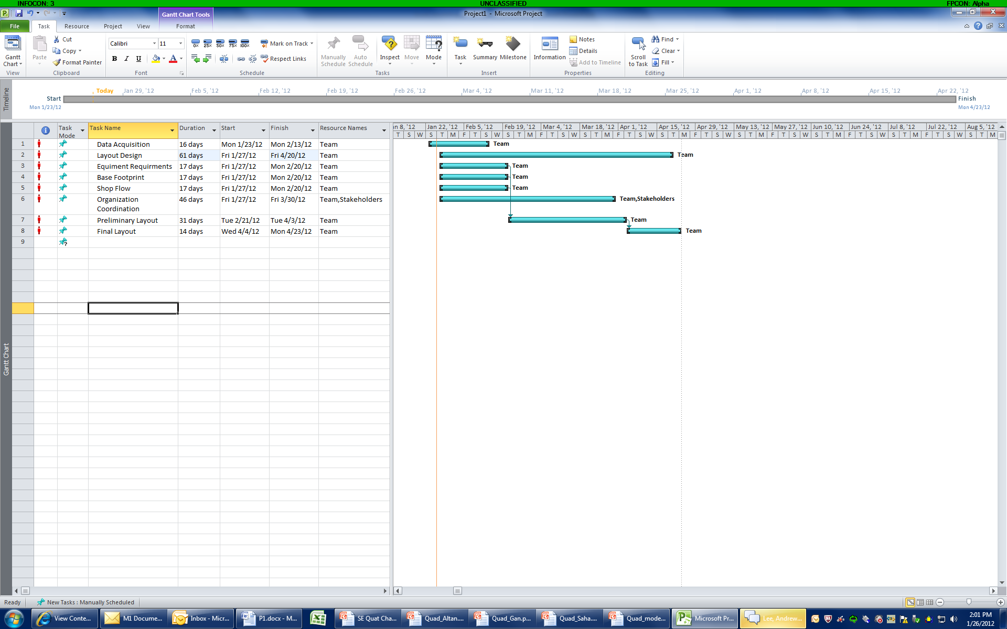

5.1 Rational for Operational Need
One of the best ways to educate students is to give them a hands-on experience in a real working environment in addition to theoretical teaching in classroom setting.

6.1 Rationale for 8 Systems Engineering Documents Set
With these documents we are describing how the Tinker Air Force Base QVC lab layout redesign works. We should be able to give these documents to another lab and they should be able to copy our program and set up a program better, faster, and cheaper at their own.

7.1 Glossary
AFMAN – Air Force Manual
AMXG – Aircraft Maintenance Group
ASME – American Society of Mechanical Engineers
CAD - Computer Aided Design
COTS - Commercial Off The Shelf
MXSG – Maintenance Support Group
QVC – Quality Verification Center
TO – Technical Order

Project Customer Requirements Document (P2)
Group 3 - Andy Lee, Mary Gravette, Andrew Freeman, Ira Bryant
February 6, 2012
1.1 Problem Statement 19
2.1 Functional Requirements 19
3.1 Cost Estimates 20
4.1 Time Constraints 20
5.1 Available Technologies 20
6.1 Required Interactions 21
7.1 Standards, Specifications and Other Requirements 21
8.1 Rationale for Project 21
9.1 Glossary 22

1.1 Problem Statement
Quality Verification Center Satellite Laboratory Relocation to Tinker Aeronautical Complex
This project will allow Tinker AFB to free up additional space needed for aircraft hangers for future workloads. New aircraft that are larger in size are expected to be supported at Tinker AFB in the near future and current hanger spaces are not sufficient to handle these larger aircraft. Building 2210 is scheduled to be demolished to make room for these new hangers. The QVC satellite lab that is currently in B2210 will have to be relocated into the TAC facility. This project will provide a floor plan for the new lab.

Additionally, all organizations at Tinker AFB will benefit from this move. The current lab in B2210 is small in size and capacity. The allocated 8500 sq ft space in the new TAC facility will allow the QVC to purchase larger equipment and new technology for the dimensional inspection results they provide for their customers. This new lab will be designed with the customer in mind and will try to eliminate long turnaround times, bottlenecks and part rejection due to size constraints that are currently seen in both the main and satellite QVC labs.

2.1 Functional Requirements
The customers of the QVC lab bring parts, systems and assemblies to the lab for inspection. The project flow through the lab can be seen in Figure 1. These projects are very diverse in size and complexity. A plan for large component entry into the QVC lab with a lifting devise to place the component on an inspection machine will be needed. These components/systems must be able to acclimate to room temperature as per the Standards, Specifications and Other Restrictions section of this document. Once parts have been acclimated to temperature, they should be inspected and returned to the customer with their results. Part flow through the lab will depend on the complexity of the inspection parameters. Multiple pieces of equipment will be utilized on one component for the inspections needed. Considerations of size and weight of the components will be considered in the flow through the lab.
In addition to lab space, an administration area will need to be considered in the design of the floor plan. Engineers, Engineering Technicians and Managers will all utilize this space. They will conduct meetings and briefings with customers and employees of the lab, discuss blueprints that are large in size, house a small break area and should have desk space for an anticipated 7 workers and 1 manager. This space will be shared with another organization that will be relocated into this same 8500 sq ft of space. That organization will be allocated a 2000 sq ft space and will utilize the small break area as well. Security in the QVC lab will need to be considered, as projects are seen with higher classification levels at times. We will not detail in our floor plan the foot print or requirements of the other organization for this project. We will only take into consideration the QVC lab.

The lab itself once complete is expected to have a life expectancy of at least 30 years. The Floor Plan will be expected to house new equipment and new technology as they are needed.

Incoming Project Que
(Customer Dropoff)

Supplementary Part Drawing Generation
Consult with Engineers
Project Log/Review
Part Acclimation

Hand Tools
Optical Inspection
Inspection Process
&
Inspection Report
Generation

Coordinate Measuring Machine Inspection
Surface Inspection

Roundness Inspection
CAD Model Generation

Completed Project Que
(Customer Pickup)

Figure 1: QVC Project Flow

3.1 Cost Estimates
Without actually obtaining contracts from outside vendors, it is estimated that the cost of this project will be $4 million. The cost of this project will be met regardless of estimate differences in actual cost. The benefit to the government to protect multiple multi-million dollar aircraft from storm damage while in an overhaul state will greatly overshadow any additional cost of this project. For this class however, there should be no outside expenses associated with the design of the floor plan only. The only costs that are foreseen may be at the price of the local copy shop.

4.1 Time Constraints
For the project, the schedule of documents as seen in document M1 Deliverables will be all that is needed for completion of this project. Project timelines will vary with student’s schedules. It is estimated that students will spend approximately 10 hours per week working on this project. After completion of the floor plan, a hard copy and digital AutoCAD drawing of the new QVC layout will be delivered to Ron Camacho, supervisor of the QVC lab, and to Dr. Allen instructor of this class no later than 2 May 2012.

5.1 Available Technologies
For the duration of this project, multiple computer systems and programs will be utilized by the group members. The most prevalent of these systems will be the students’ laptop computers with Microsoft Office software and the use of AutoCAD and SolidWorks when available. Printing capabilities will be utilized on the OU campus and the local printing shops, as well as the existing QVC large plotter systems for larger layout capabilities.

6.1 Required Interactions
Many outside organizations will need to be coordinated with for the completion of this project. They are:
PMEL – for coordination of 2000 sq ft storage space
AMXG – Projected workloads for new QVC lab (current/future)
PMXG – Projected workloads for new QVC lab (current/future)
CMXG – Projected workloads for new QVC lab (current/future)
OC-ALC/GK – Future workload requirements
SCMW – Future workload requirements
MXSG – Design guidelines/standards, construction limitations, transport limitations
Numerous OEM’s - equipment requirements/issues related to transportation, contract issues relating to transport of equipment
Numerous Plant Maintenance Contractors (Telephone, LAN, Electric, etc) – facilities issues, scheduling, contract issues
QVC Personnel – Provide input on project flow/analysis issues

7.1 Standards, Specifications and Other Requirements
All industry standards associated with an industrial inspection area shall be abided by according to all state, federal and military regulations. In addition to these regulations, the following standards, Operational Instructions and regulations will be followed:
AFMAN 32-1094, Criteria for Air Force Precision Measurement Equipment Laboratory Design and Construction, 1 November 1998
ASME Y14.5M-1994, Geometric Dimensioning and Tolerancing, Reaffirmed 2010
MXSG OI 61-201, Test Quality Instructions for Metrology Functions, 24 January 2012
T.O. 00-20-14, Air Force Metrology and Calibration Program, 30 June 2009

7.1 Facility Requirements
Environment – maintain 68° ± 1°
maintain 20 – 50% Relative Humidity
maintain positive pressure airflow
Handicap accessible

8.1 Rationale for Project
This project consists of a designed floor plan to relocate the QVC. The rationale behind the floor plan is to free up valuable physical space to allow Tinker AFB to build new hangars to store newer aircraft for overhaul/modification.

9.1 Glossary
AFMAN – Air Force Manual
AMXG – Aircraft Maintenance Group
ASME – American Society of Mechanical Engineers
CMXG – Commodities Maintenance Group
MXSG – Maintenance Support Group
OC-ALC – Oklahoma City Air Logistics Center
OC-ALC/GK – Aerospace Sustainment Directorate
OEM – Original Equipment Manufacturer
PMEL – Precision Measurement Equipment Laboratory
PMXG – Propulsion Maintenance Group
QVC – Quality Verification Center
SCMW - 448 Supply Chain Management Wing
TAC – Tinker Aeronautical Center
T.O. – Technical Order

Management Derived Requirements Document (M3)
Group 3 - Andy Lee, Mary Gravette, Andrew Freeman, Ira Bryant, Terry Anderson, Jose Berrios
February 20, 2012
1.1 Technical Description of the Problem Statement 24
2.1 Inputs, Outputs, and Functional Requirements 24
3.1 Customer Requirements and Additional Requirements 25
4.1 Requirement for Product Lifecycle 26
5.1 Requirements Based on Cost and Schedule 26
6.1 Schedule Requirements 26
7.1 Glossary 29

1.1 Technical Description of the Problem Statement
The current location of the QVC laboratory is being forecasted to be used by the maintenance group. Therefore, the QVC facility will be relocated from Bldg. 2210 to the Tinker Aeronautical Center (TAC), previously known as the General Motors Assembly Plant. Due to the continuous maintenance requirements of the warfighter, interruptions to the daily tasks of the QVC facility must be kept to a minimum. To accomplish this task and with the guidance of Dr. Janet Allen’s expertise in systems engineering, Group 3 will develop a plan to complete the move with minimal interruptions of support to the warfighter.

2.1 Inputs, Outputs, and Functional Requirements

There will be multiple inputs to this project and several outputs, to include the final deliverable of the floor plan for the new location of the QVC facility. Every input will have an effect on the successful outcome of this project. Constraints and regulations must be adhered in order to be accepted by the Tinker AFB personnel. It is the responsibility of Group 3 to be thoroughly versed in all aspects of this project where their expertise can be best utilized. Effective communication between team members will also be required to ensure that all requirements of the customer are met. Attached at the end of this document is a function structure of the management process. This function structure outlines the flow of information, decisions, and people regarding the successful management of this project.

  - 2.1 Time Scale
The lifetime of the QVC Facility Layout project will be the spring 2012 semester. The team members will commit, on average, 10 hours per week.

  - 2.2 Inputs
1. Students with a lack of knowledge and experience of Systems Engineering
a. Students with CAD understanding
b. Students with structural engineering understanding to evaluate the feasibility of the layout
c. Students to ensure that placement of equipment does not interfere in an emergency situation
2. Resources (time, knowledge, money, and supplies)
3. Faculty
4. Industry Advisors (Tinker AFB QVC personnel – understanding of equipment and part flow)

  - 2.3 Outputs
1. Students with knowledge and experience of Systems Engineering
2. Facility Layout:
a. Preliminary Layouts
c. SWOT of Preliminary Layouts
b. Final Facility Layout

The top-level function of the QVC Facility Layout is described in the figure below:

Students with a lack of Systems Engineering knowledge & experience

Students with Systems Engineering knowledge & experience

Educate students

Design Tinker Air Force Base QVC Facility Layout

Resources
(time, knowledge, money, and supplies)

Facility Layout
Faculty
Legend:
Industry Advisors
Inputs
Functions
Outputs

Figure 1: The Top Level Function of the QVC Layout

3.1 Customer Requirements and Additional Requirements

The overall customer requirement will be to accomplish the design of the QVC facility. In order to successfully design the layout, careful planning and coordination will be required. The following list points out the requirements and who will complete them.
- Equipment survey, technical personnel will be required to identify the requirements of the equipment to function properly (i.e. space requirement, power source 110 or 240 volts, temperature, etc.).
- New site survey, the group will visit the new site and determine the most appropriate layout of the equipment for proper functionality. They will also identify work required in the facility to support the functionality of the equipment.
- Facilities personnel will be required to complete any work identified in step b. (i.e. electrical wiring, air, plumbing, internet access, etc.).
- Equipment usage, the group will investigate the usage of each piece of equipment. This information will be used to aid with equipment placement in the facility layout to facilitate the flow of parts inside the lab.
- Classified parts, the group will determine if any work is classified thus impacting how it is stored in the facility. The group may need to comply with the AF standards to ensure a secured designated area is incorporated into the design.
- Hoisting equipment, the group will determine if the rating of the existing hoisting equipment is sufficient for the larger pieces of equipment planned for purchase.
- Vibration effect, the team will research the surrounding areas outside of the lab to check for any high vibration equipment (i.e. heavy vehicles traversing, sheet metal forming machine, or cranes) to prevent harmful impacts to the highly sensitive and calibrated machinery along the walls inside this lab.

4.1 Requirement for Product Lifecycle

The requirements for the product lifecycle include items that could occur beyond the design of the facility layout. This considers both outside factors and potential issues that may come up in the future. These will be incorporated into the design to attempt to make the layout as flexible as possible to include for any future growth. The following list is the product lifecycle requirements to be considered in the design.
- It is understood that the layout designed for the QVC lab will not be permanent. Initial preparation for possible short term layout changes will be made. Long term changes will also be addressed. Product Lifecycle issues will be addressed by: Not all measuring equipment located in the current QVC is part of the QVC work flow, and these machines sit mostly unutilized. These machines will still stay in the QVC inventory when the move occurs, but will be replaced by other equipment in the relatively short term. Provisions for removing this equipment will be reflected in the layout.
- The larger floor plan of the new location will allow new equipment to be purchased. The capabilities, size requirements, and position in the workflow for projected new equipment will be provided for in the layout.
- More technologically mature machines have a higher probability of being replaced earlier. The maturity level of the existing machines will be examined and their eventual replacement will be addressed.
- Environmental requirements may change with the addition of new equipment added later. The steps necessary for lowering environmental tolerances will be examined.
- The layout will address manpower levels both at and above current requirements, so growth in the lab will be provisioned for.

5.1 Requirements Based on Cost and Schedule

The associated costs will be addressed by the assigned program managers at Tinker Air Force Base. Group 3 will primarily continue its effort as planned by developing the new facility layout design and the schedule as previously documented in M-2. Again, the goal of this new configuration is to reduce turnaround time, and eliminate bottlenecks such as limited space for parts acclimation and parts rejection.

6.1 Schedule Requirements

Many of the steps in the schedule requirement will overlap and happen in concurrence to better utilize each team member and the schedule while still providing a collective and productive environment. The team will meet on Wednesdays after class to talk about the tasks to be done that week and divide up the workload. The team will then meet back up on Sunday to share information gathered and refine the assignments before they are submitted. The team will consistently be in contact with the customer to ensure the team is both designing what the customer needs and to best manage any expectations of the customer. There are two main sections of the schedule requirements: acquire data and create layout. The deliverables will be produced when the facility layouts are created.

6.1 Acquire Data
The detailed process steps to be taken to achieve the deliverables are to initially acquire any required data. This includes the preliminary steps of creating the detailed plan for the project. This is an ongoing task that will be revisited and adjusted as necessary throughout the course of the project. This allows the team to make minor changes to the schedule as long as the final deliverable dates are met while keeping the customer informed of these changes. At this time, a site visit is required to get an appreciation for the current location and equipment used in the area and to understand the new location the shop will reside. The equipment and allocated space requirements will be obtained to include all the requirements mentioned under the Customer Requirements and Additional Requirements section of this document. Once the requirements are obtained, the team will talk with Subject Matter Experts (SMEs) to acquire a shop flow to aid with the new locations of the equipment and better utilize the space allocated for the QVC shop. Shortly after this step begins, the team will also start to prepare for a layout exercise.

  - 6.2 Create Layout
The first milestone and deliverable will be the two or three layouts created during the layout exercise. The second milestone and deliverable is the strengths, weakness, opportunities, and threats (SWOT) chart the team creates to analyze each layout. This will guide the team to rank each layout and make any necessary compromises to develop the final facility layout. The third and final milestone and deliverable is to create the final facility layout. The team will then take the final layout and make any necessary touches before handing off this milestone and deliverable to the customer.

6.2.1 Deliverables
  - Preliminary Layouts
  - SWOT of Preliminary Layouts
  - Final Layout

  - 6.4 Detailed Schedule
The detailed schedule requirements of the QVC Facility Layout are shown in the Gantt chart below. There is a direct correlation to the Systems Engineering Diagram following it. They have been connected by a numbering system (0-6) to identify the steps being taken in each diagram. As Figure 2: QVC Facility Layout Systems Engineering Diagram depicts, step 0) is reevaluate progress and solutions which is intended to be done between the team and the customer as an ongoing process. This is to ensure that the team is doing both the right solution (validate) and the details in the design are correct (verify) to avoid unnecessary work and cost to rectify any inaccuracies.

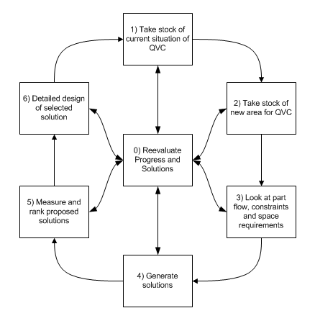
Figure 2: QVC Facility Layout Systems Engineering Diagram
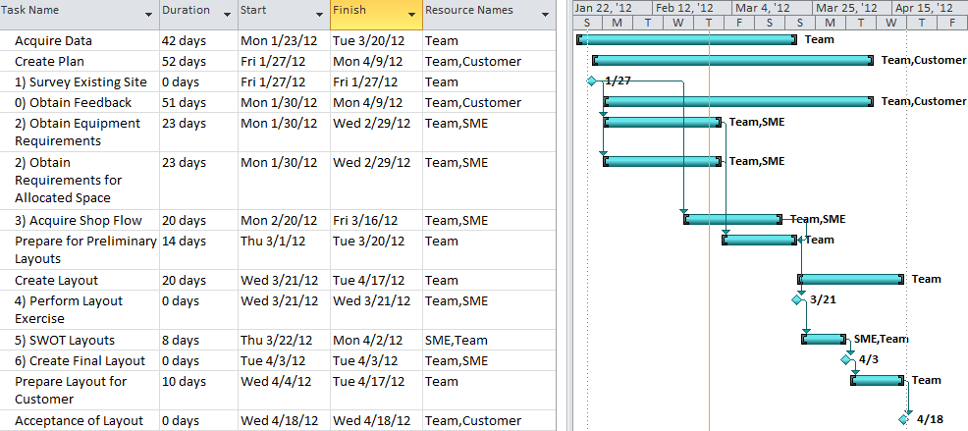
Figure 3: QVC Facility Layout Gantt chart

7.1 Glossary

AFMAN – Air Force Manual – contains information, policy, procedures, and mobility instructions.

AMXG – Aircraft Maintenance Group

ASME – American Society of Mechanical Engineers

B2210 – Building 2210 on Tinker AFB - houses QVC lab for transfer to TAC facility.

CAD – Computer Aided Design

COTS – Commercial Off The Shelf

MXSG – Maintenance Support Group

SME – Subject Matter Expert

QVC – Quality Verification Center – provides precision measurement for all aircraft engines, components, parts, and aircraft commodities, conventional and advanced weapon systems and subsystems .

TAC – Tinker Aeronautical Center – Name given to building 9001 on Tinker AFB. This building houses multiple organizations that provide services during the industrial processes of aircraft, engines, commodities and weapon systems overhaul or manufacture.

T.O. – Technical Order - an official source document for engine limits, rates, and factors used in management of the Air Force engine inventory.

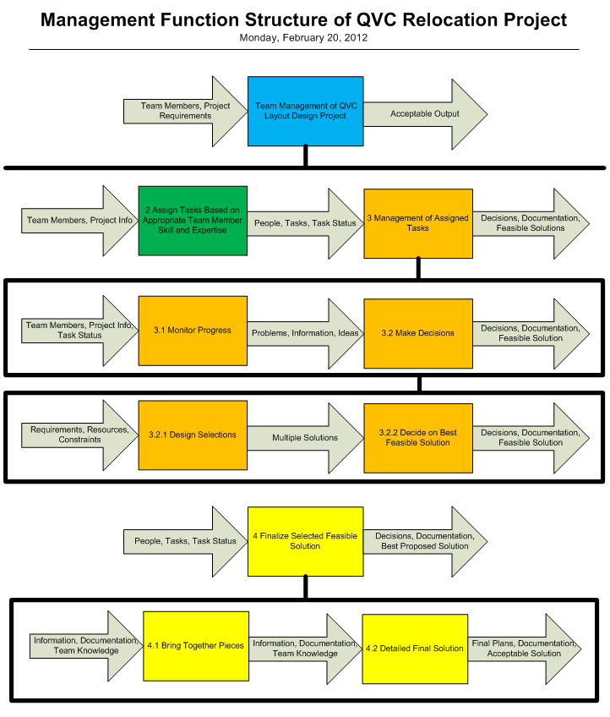

Project Derived Requirements Document (P3)
Group 3 - Andy Lee, Mary Gravette, Andrew Freeman, Ira Bryant, Terry Anderson, Jose Berrios
February 20, 2012
1.1 Project Requirements 32
2.1 Technical Requirements 32
3.1 Customer Requirements 33
4.1 Current QVC Lab 33
5.1 Existing Area Designated for New QVC Lab (proposed) 33
6.1 PMEL Area 34
7.1 Utilities 34
8.1 Environmental Controls 35
9.1 Administrative Area 35
10.1 Conference/Meeting Area 35
13.1 Engineering Consultation 37
14.1 Engineering Drawing Requirements/ Solid Model Design 37
15.1 Supplementary Drawing Requirements 37
16.1 Project/Part Acclimation 37
17.1 Project/Part Movement in Lab 37
18.1 Technology Requirements/Inspection Processes 38
19.1 Project Report Generation 40
Appendix A 43

1.1 Project Requirements

Quality Verification Center Satellite Laboratory Relocation to Tinker Aeronautical Complex

This project will allow Tinker AFB to free up additional space needed for aircraft hangers for future workloads. New aircraft that are larger in size are expected to be supported at Tinker AFB in the near future and current hanger spaces are not sufficient to handle these larger aircraft. B2210 is scheduled to be demolished to make room for these new hangers. The QVC satellite lab that is currently in B2210 will have to be relocated into the TAC facility. This project will provide a floor plan for the new lab.

2.1 Technical Requirements

Technical aspects of the design of the QVC lab layout will include:

    - Customer Requirements
a) QVC Lab Personnel
b) QVC Customers
- Current QVC Lab
    - Existing Area Designated for the New QVC Lab (proposed)
    - PMEL Area (in conjunction with QVC area)
    - Utilities
a) Shop
b) Equipment
c) Overhead Bridge Crane
d) Network
e) Communications
    - Environmental Controls
    - Administrative Area
    - Conference/Meeting Area
    - Security
    - Project/Part Flow
    - Engineering Consultation
    - Engineering Drawing Requirements/Solid Model Design
    - Supplementary Drawing Requirements
    - Project/Part Acclimation
    - Project/Part Movement in Lab
    - Technology Requirements/Inspection Processes
      - Hand Tools
      - Optical Inspection
      - Surface Profile Requirements
      - Roundness Inspection
      - Coordinate Measuring Machine Processes
      - Use of CAD modeling
- Project Report Generation
- Other Considerations
- Cost Approximation
- Schedule
- Alternatives

These requirements will all be discussed in detail in the body of this document.

3.1 Customer Requirements

3.2. QVC Lab Personnel
The personnel in the QVC lab will be the primary customers of this project. The design of this layout should provide them with the most readily accessible working environment for their projects. These projects have a variety of sizes, shapes, weights and processes to be accommodated throughout their inspection processes. It will be our job to maximize the use of this allocated space while making project/part transition throughout the lab efficient as well.

3.3. QVC Customers
While QVC personnel will be our primary customer, the ease of use for QVC customers should also be taken into account for this project. The ease in which their customers can access QVC engineers, technicians and equipment will be an aspect of design consideration as well.

4.1 Current QVC Lab
The existing QVC satellite lab in B2210 currently inspects smaller components and assemblies that are commonly utilized in the CSD of the engine. Projects are also sent to the lab from the main lab in B3001. These projects are usually overflow projects from that lab due to the large project bottleneck on the larger equipment. These projects usually push the limits of size capacity on these pieces of equipment. Often, projects are turned away in both labs on the basis of inadequate volumetric capacity of the equipment. This to the QVC personnel is unacceptable. This project should take into account large scale workloads and future proposed equipment purchases to alleviate this problem. The current footprint of the QVC lab in B2210 is seen by clicking the icon below. A sample of a large component being inspected on the largest CMM in both labs is also seen by clicking on the appropriate icon.

5.1 Existing Area Designated for New QVC Lab (proposed)

The QVC has been allocated 8100 sq ft of floor space in the newly acquired TAC facility. The area is typically open, with the exception of two existing building columns, square in footprint and located in the northwest area of the building. Electronic and hard copy AutoCAD drawings of this area are available that show the surrounding proposed facility utilities, shops, aisle ways and any other areas of concern. These drawings are not for public release, but for purposes of this class, may be reviewed by students. This space can be seen by clicking on the icon below. The drawing shows the open area for the designated QVC and PMEL area. We will not be designing the new PMEL area, but will need to take into account that 2000 sq ft of this area will be utilized by PMEL for storage, equipment and personnel. The remaining 6100 sq ft will need to be designed to facilitate the new QVC lab, administrative areas for the QVC personnel, and a joint use meeting/conference area for both the QVC and PMEL use. All utilities in the existing building are overhead and will need to be coordinated with the appropriate contractor for design and specification after requirements are determined. For this project, we will determine all utility requirements and list them, but not contact any outside contractors at this time. There shall be no design that includes the degradation of existing structural components of the permanent structure.
6.1 PMEL Area
As stated in section 5.0 above, the design of this floor plan will allocate 2000 sq ft to the PMEL lab for its use. This area will need to be easily accessible through walk in doors from at least 2 aisle ways and be able to access the meeting/conference area for common use. There will be no special utility requirements for this area.

7.1 Utilities
7.1. New Facility
Standard power receptacles and lighting commonly associated with industrial use should be incorporated into the lab inspection area, with the same common practices seen in the administrative and meeting areas as well. The lab inspection facility will require shop air at 100 psi for multiple pieces of equipment. This air should be in the walls and ample connection points scattered throughout the lab as noted in the proposed new floor plan.
7.2. Inspection Equipment
All inspection equipment in the lab runs on standard 110V power. Some pieces of equipment will utilize the supplied 100 psi shop air. No other requirements for the inspection equipment are required.

7.3. Overhead Bridge Crane
There will be accommodations made in the new inspection area for a “high bay area.” This area will allow the QVC personnel to equip the lab with a bridge crane structure for use on future required large scale inspection equipment. This equipment will be purchased in conjunction with this move. Upon determination of which crane structure will be best suited for the QVC lab, the utility requirements will be released.
7.4. Network
QVC lab personnel will require all administrative computer systems, printers, plotters, scanners and overhead projectors/televisions to be connected to the Tinker network. In addition to the Tinker network, all inspection equipment will require a lab server and network system to cut costs associated with dedicated printers for each piece of equipment. This network will have 1 printer connected to the inspection equipment for documentation purposes and will NOT be connected to the Tinker network. Ample drop points will be noted.
7.5. Communications

All phone systems will be noted throughout the floor layout. Each administrative area will have its own drop point and ample drops scattered in the lab inspection areas will be positioned accordingly. This phone system should include an intercom system as well.

8.1 Environmental Controls
The QVC lab follows tight guidelines associated with their environmental conditions. These conditions can be found in the documents that are referenced at the end of this document. To summarize the most important of these requirements, the QVC lab environment must maintain 68° ± 1° F, 20-50% relative humidity, positive pressure and must be as vibration free as possible. No special foundation requirements must be met at this time, but concern with surrounding shops vibration frequencies must be taken into account. For the QVC to be able to meet these requirements, a building must be constructed inside the TAC facility to house all the laboratory equipment.

9.1 Administrative Area
The administrative area should be designed for at least 7 lab personnel and 1 supervisor. All areas should include a desk, filing systems, computers and all necessary components for them to carry out their daily tasks associated with the lab. The area should also include networked printers, copiers and a plotter/scanner for larger part drawing generation. All common utilities associated with administrative areas will need to be coordinated with the appropriate contractor to insure completion in conjunction with construction of this area. This area does not need to be climate controlled to the extent of the inspection area to save in energy costs. This area shall be independent of the controls of the laboratory.

10.1 Conference/Meeting Area
The design should include an area that can be used for meetings, conferences with customers/vendors, briefings and also include a small break area. This area will be utilized by both the QVC personnel and PMEL personnel. All utilities within this area will need to be coordinated with the appropriate contractor as well. This area will also include a promethean board or flat screen television, or both, which will include accessibility by both computers from the PMEL and QVC areas for briefings and meetings by power point presentation. When not giving presentations by computer, the flat screen television will be hooked up to the Tinker cable network. This area can be under the same climate controls as the administrative area.
  - Security
The QVC areas will need to be secure at all times from unauthorized personnel. These areas sometimes receive projects of classified security. Therefore, all doors leading into the QVC areas will be protected by cipher lock systems. These systems will need to be accessible by only QVC personnel.
  - Project/Part Flow
Customers of the QVC bring projects to the lab by forklift, pallet jack, crate or by hand. These projects vary in size and weight. For larger projects, an overhead door will need to be placed for easy access into the lab area and acclimation area. Double walk through doors will also need to be placed in the front area of the lab for smaller projects. Once in the lab acclimation area, parts will need to sit for 24 hours prior to inspection. During this period, the QVC engineers will review the project and determine if any supplementary drawings or data will need to be obtained. After the acclimation period and review, the project will be placed into a queue for inspection. While in this queue, engineers and technicians will determine which project is placed as the highest priority and is then moved to the appropriate equipment for inspection. Projects requiring heavy lifting will remain closer to the front of the lab area. This area will be designated the “high bay area” as equipment placed in this area will have a bridge crane structure overhead for heavier components. This area will need to be designed for at least 15 feet of clearance by the equipment, as well as any other necessary clearances for the bridge crane structure. Projects may require more than one type of inspection technology as described in section 18.0 during the inspection process. Once the inspection process is completed, the report is reviewed by engineers and completed. The customers are then called to pick up the project and review with engineers for further guidance. Figure 12.1 below shows the project flow diagram for the labs.

parts
QVC Project Inspection Processes
QVC Project Acclimation
QVC Project Consultation
QVC Customer
Engineering Review

papers

Project Flow
If Necessary
Solid Modeling of Components
JEDMICs, T.O.’s ECO’s, OEM Print
OEM Electronic Data, QVC design
Engineering Drawing Generation

Figure 12.1 QVC Project Flow

13.1 Engineering Consultation
QVC personnel are consulted prior to project inspection to insure correct inspection processes and criteria are met. Most times, this consultation is done in the front of the lab at a front desk. Drawings are used along with any other supporting documentation on what inspections are to take place. Once the project is completed, another consultation is done to discuss the results and if any other inspections are necessary.
  - Engineering Drawing Requirements/ Solid Model Design
Some projects will require very detailed engineering drawings or solid models for inspection purposes due to the complexity of the components. Engineers will determine if any engineering drawings are available in the Tinker networked JEDMICs database, by requesting them through OEM contact, or by Air Force T.O. If the system components to be inspected require solid modeling, the solid model is requested, if available. If there is no available solid model, the QVC personnel will design a solid model in SolidWorks software for inspection purposes only. This model will be inserted into the machine software and component parts inspected accordingly. Access to computers in the lab area that are networked to the Tinker network and have the necessary software will be included in the floor plan.
  - Supplementary Drawing Requirements
Supplementary drawing requirements include those drawings that may or may not be included in the machining phase of the component brought to the lab for inspection. These drawings will be those of the casting, alternate manufacture, or alternate assembly instructions. Also included in these would be the engineering change notices for the component being inspected. Engineers in the QVC lab will need access to these types of drawing databases as well all engineering drawings and solid models of components/parts.
  - Project/Part Acclimation
As stated in section 12.0 of this document, the projects brought into the lab for inspection will require an acclimation process. This process requires the components to acclimate to room temperature prior to inspection for at least 24 hours. The current lab has no space allocated for this acclimation process, and therefore, has to find an area inside the inspection area to place parts while coming to room temperature. This lends itself to overcrowding of the inspection lab, safety hazards, and space concerns. A room designated for acclimation of parts of all sizes is needed outside the main inspection areas. This will allow the acclimation process to take place while freeing up valuable floor space for movement of parts and safety of personnel from tripping hazards. This space will need to be designed to take in any size component that could come to the lab for inspection. However, the primary way components are brought to the lab is by pallet. Optimum use of this space will provide ample storage space for palletized projects.

  - Project/Part Movement in Lab
As mentioned above, the primary way components are brought into the lab is by pallet. These pallets are moved around the lab by hand by the use of a pallet jack. During the inspection process, many projects are being simultaneously worked on by engineers and technicians in the lab. Project movement in the lab will require ample space between equipment to insure movement can happen with no inconveniences to other projects being inspected. This in itself would lend designers to keep larger projects in the front of the lab, with the smaller projects in the back.
  - Technology Requirements/Inspection Processes
There are many inspection processes in the lab with differing technologies. Each project that comes into the lab will require its own unique inspection plan. This plan may require multiple different pieces of inspection equipment. This equipment will be described in detail in the following paragraphs. During the transfer, none of the inspection equipment may be exposed to the elements of outside weather. They must be kept indoors, preferably in a controlled environment. OEM specification sheets and information for numerous pieces of equipment currently in use in the B2210 QVC lab can be seen in Appendix A by clicking the appropriate icon.
18.1 Hand Tools
The hand tools utilized in the QVC lab associated with inspection are micrometers, calipers, gage blocks, pin gages, fixturing tools and surface plates. All of these tools are neatly placed into cabinets throughout the lab. These cabinets vary in size and shape, but will not weigh in excess of 750 lbs and can be easily moved by pallet jack or forklift with minimal prep work.
Processes of inspection with this type of equipment require ample space for movement around the components being inspected. Projects are usually hand carried to a specific desktop area where drawings can be laid out and viewed while inspection is taking place. Projects requiring surface plate operations will need to be accessed from at least three sides of the plate for optimum use of the inspection tools. No lifting devices are mandatory for this equipment.
18.2 Optical Inspection
The optical inspection tools utilized in the QVC lab consist of three components; two OGP Flash systems, a 250 and 400 series, and an OGP OQ-30B optical comparator. These three systems will require the OEM to stow the equipment prior to movement due to the linear glass scale measurement media. Computers and any peripheral equipment will need to be disconnected and moved separately. Once the equipment is stowed, an air-ride system will be needed to reduce vibration associated with movement of the equipment. Once movement is completed, the OEM will need to set-up and calibrate the equipment prior to use to insure integrity of the equipment.
Inspections using this equipment are very diverse. For optimum use of this equipment, it will be necessary to set a pallet in front of the equipment with no effects of safety or code violations. Projects going to these pieces of equipment are commonly small in size; however, a few components are larger in size and shape requiring a larger space to work with around the equipment. No lifting devices are mandatory for this equipment.
18.3 Surface Profile
A Mahr XCR-20 Contour Measuring Station is used for all surface parameters. This equipment is a desktop model that will need to be moved in three units; the surface plate and measurement stand, computer system and desk area. This equipment does not require the OEM to stow prior to movement, but will require them to set-up and calibrate after completion of the move.
This equipment requires space to the left of the operating stand for fixturing and holding components in any orientation for inspection. Generally, all components fit on the surface plate of the stand, but some larger components will not and will require more fixturing and creative ideas to orient the parts for inspection. In the current lab as seen in the existing footprint, the surface plate sits directly to the left of the contour measuring machine. This sometimes creates a problem with larger components. No lifting devices are mandatory for this equipment.
18.4 Roundness Inspection

Projects requiring roundness parameter inspections are currently measured on a small PDI IndiRon 100 roundness gage. This gage has a working table of 8” in diameter, requires 110V electric power and 100 psi shop air. This air is routed into a regulator and air dryer prior to being utilized by the machine. No special equipment other than a pallet jack or forklift will be required for the move. Upon completion of the move, the OEM will be contacted for calibration of the equipment.
Projects are usually carried to this equipment by hand, as they are normally small in size and weight. A desk area with room to view engineering drawings is preferred, with some floor space for possible palletized multiple part projects.

The new floor plan should make provisions for a new large scale roundness gage. This requirement will be purchased by the QVC engineers and will be placed under the overhead crane for its use. No special utilities will be required other than 110V electric and 100 psi shop air. Footprint requirements for this piece will be estimated from current equipment possibilities that have been selected from QVC engineers. Adequate floor space for project pallets and floor jack movement is necessary for this piece of equipment.
18.5 Coordinate Measuring Machine Processes

The QVC lab’s workhorses on project inspections are the CMM’s. The B2210 lab currently utilizes 2 CMM’s. The Zeiss Prismo can accommodate larger part inspections that may require lifting devices. Placement underneath the crane would be optimal. There are 3 cabinet pieces, control box and an air dryer associated with this equipment that will need to be placed close to this machine. There are no special utilities required; 110V electric and 100psi shop air are all that is required.
The Zeiss Contura G2 is a small CMM and can be placed for easy access by smaller components. 110V electric and shop air are required. Desk area, air dryer and control box will be placed accordingly.
The lab personnel are expecting this new area to alleviate a bottleneck of large scale project workload. In the plans for this move, the QVC Engineers have put in place the requisition package for a large scale CMM. The floor plan should include an area for this large scale CMM. The exact footprint is not known, but an area 12 ft x 15ft underneath the bridge crane should be sufficient per QVC personnel.
18.6 Use of CAD Modeling
QVC engineers utilize SolidWorks and some applications in AutoCAD for modeling of components for inspection. These software systems will be required at the administrative areas in the floor plan, but QVC personnel would like for a standalone system to be integrated into the lab inspection area for ease of transferring models to the appropriate equipment. No special accommodations are necessary other than the standard computer desk allocations.

19.1 Project Report Generation

Project report datasheets are written by engineers prior to inspection by the engineering drawings supplied by the customer. The datasheets are taken to the inspection lab and placed with the project for documentation of inspection results. Once the inspections are completed, an engineer will review the data and consult with the customer to determine if any other dimensional inspections are necessary. These reports are generated by computer, printer and plotter/scanner. Adequate access to these services is necessary in the lab as well as in the administrative areas.

  - Other Considerations

There will be outside governing issues that affect the floor layout as well. The QVC typically does not associate any pattern of recurring projects. Projects coming in always require differing inspection practices and some form of modular fixturing design to hold projects while inspections are taking place. The fixturing devices are located in the shop accessory cabinets at a convenient location in the lab. These cabinets will be accessed throughout the day by all personnel in the QVC lab.
These projects also vary greatly in size and shape. The ease of which a large wing panel can be transferred in and out of the lab should also be considered, as well as any future workloads that Tinker AFB is projecting that may be brought to the lab for inspections.

  - Cost Approximations

There are no costs projected for this design phase of the QVC Floor Plan. All aspects of this requirement can be accomplished with current facilities and equipment owned or accessible to students and employees of the QVC lab.

  - Schedule

The schedule of the only deliverable provided by this project will be met by meeting the completion date of 11 May 2012. Prior to the end of the work day on this date, all documents of this project, including a designed floor plan for the new lab, and any justifications on placement of equipment will be turned in to Dr Allen for class purposes and Mr Ron Camacho, Chief of the Quality Verification Center Section for review.

  - Alternatives

There are many different alternatives for this project. These alternatives include; not moving the lab, moving to a different location, expanding the B3001 lab to accommodate all B2210 equipment and expansions and contracting out all inspections. These alternatives have been discussed by Tinker AFB and the QVC Personnel and have been deemed “Unacceptable due to unlimited cost differentials.” The QVC will be moved to the TAC facility. Alternatives to the design of the floor plan can be found by showing at least 2 different scenarios for equipment placement. For this project, students will design 2 floor plans and list advantages/disadvantages for each.

  - References

All items listed in this section have been reviewed for consistency. This project will comply with all specs, standards and requirements that are in place for the design of this project.
AFMAN 32-1094, Criteria for Air Force Precision Measurement Equipment Laboratory Design and Construction, 1 November 1998

ASME Y14.5M-1994, Geometric Dimensioning and Tolerancing, Reaffirmed 2010

MXSG OI 61-201, Test Quality Instructions for Metrology Functions, 24 January 2012

T.O. 00-20-14, Air Force Metrology and Calibration Program, 30 June 2009

  - Glossary
AFB – Air Force Base

AFMAN – Air Force Manual – contains information, policy, procedures, and mobility instructions.

ASME – American Society of Mechanical Engineers

B2210 – Building 2210 on Tinker AFB - houses QVC lab for transfer to TAC facility.

B3001 – Building 3001 on Tinker AFB - houses QVC main lab and numerous industrial shops.

CAD – Computer Aided Design

CMM – Coordinate Measuring Machine

CSD – Constant Speed Drive – term for the gearbox that the industrial shop housed in B2210 repairs/overhauls

ECO – Engineering Change Order – document used to track changes to production blueprints and technical orders

JEDMICS – Joint Engineering Data Management Information and Control System – database of all engineering documents used by the Department of Defense

MXSG – Maintenance Support Group – provides facilities maintenance, equipment maintenance and repair, physical sciences, weapons systems and precision measurement equipment laboratories, transformation, and environmental, fire and occupational health.

OEM – Original Equipment Manufacturer

OGP – Optical Gaging Products – manufacturer of vision systems used by Tinker AFB

PDI – Precision Devices Incorporated – manufacturer of the roundness gage used by the QVC lab in B2210

PMEL – Precision Measurement Equipment Laboratory – measures and tests government-owned systems and equipment as well as repairs, calibrates and certifies equipment at regularly scheduled intervals

QVC – Quality Verification Center – provides precision measurement for all aircraft engines, components, parts, and aircraft commodities, conventional and advanced weapon systems and subsystems.

TAC – Tinker Aeronautical Center – Name given to building 9001 on Tinker AFB. This building houses multiple organizations that provide services during the industrial processes of aircraft, engines, commodities and weapon systems overhaul or manufacture.

T.O. – Technical Order - an official source document for engine limits, rates, and factors used in management of the Air Force engine inventory.

Appendix A
General Information and Specification Sheets on Selected Equipment

Mahr 828 UN 120

OGP Opticom Qualifier OQ-30B
OGP SmartScope Flash 250
OGP SmartScope Flash 400
PDI Indi-Ron 100

Zeiss Contura G2
Zeiss SACC Prismo

Equipment Cabinet Pictures

Management Verification and Validation Document (M4)
Group 3 - Andy Lee, Mary Gravette, Andrew Freeman, Ira Bryant, Terry Anderson, Jose Berrios
March 26, 2012
1.1 Verification and Validation 45
2.1 Validation 45
3.1 Verification 47

Verification and Validation
During the initial conceptual planning stage for the QVC Facility Layout, the management team discussed methods by which the design could be evaluated, tested, and validated. Management determined that to verify and validate the final product, analysis would entail investigating the feasibility of various facility layout drawings using the paper doll tactic. However, the final design will use AutoCAD software. Ultimately, the team will perform a Strengths, Weaknesses, Opportunities, and Threats analysis (SWOT). The SWOT analysis conducted on each drawing will determine whether the final layout meets the customer’s negotiated requirements and the date for the deliverables to Tinker AFB and for the System Engineering course. As each step is critical and essential to the overall success of the design, management will focus detailed attention to involving and communicating with stakeholders (students, industry advisors, and instructor) throughout the process.

2.1 Validation
Validation is the method by which management determines if the team designs the QVC facility such that its layout configuration will meet the customer’s needs. This will be determined by conducting both operational assessment and testing as well as evaluating the lab’s utility. Inherent within the methods used to validate the design are theoretical and empirical structural and performance validity constructs.
2.1.1 Operational Assessment
Management will review the team’s alternative design proposals. This prototyping will allow
management to keep abreast of the team’s direction and provide critical feedback at the various junctures (stages of design). Additionally, during these operational assessment meetings, stakeholders will be allowed to provide their input. However during these discussions, both management and the team will be cognizant of group dynamics, the potential of scope creep, and the possibility of groupthink.

Wikipedia defines groupthink as a psychological phenomenon that occurs within groups of people. It is the mode of thinking that happens when the desire for harmony in a decision-making group overrides a realistic appraisal of alternatives. Group members try to minimize conflict and reach a consensus decision without critical evaluation of alternative ideas or viewpoints.

Furthermore, this operational assessment will provide the team the practical experience of interfacing and communicating with the end users, experience in solving real world problems, as well as a direct linkage between the theoretical knowledge gained in the classroom environment to the practical and experiential application of the material by designing the facility layout.
2.1.2 Operational Testing
Management will also require the team to meet with the end users and industry advisors prior to finalizing the design. This will allow the end-users to conceptualize how they will operate within the new facility based on the current layout. This “operational testing” will provide the user the ability to conceptually walk through the facility and compare their current working environment to the proposed layout to see if there are any unforeseen drawbacks to the equipment placement, workstation, office workspace, walk space, etc. prior to design completion. Management recognizes that a true test of this design cannot be fielded until the equipment in the new facility is fully installed and functional and is being used in the operational environment for which it was designed. These resulting experiences will provide a more accurate assessment to validate the facility design layout.

Management also considered other means by which the design could be validated. One such qualitative method was to develop, administer, and analyze the results of a survey instrument. The tool would have been designed such that the initial requirements would have been documented, scope defined, and a ranking scale incorporated into the survey instrument such that the management could have further underscored the relative importance of each requirement. Using both quantitative and qualitative feedback from the end users, the tool would have provided management with additional documentation to aid in the verification of the final design. However, due to time constraints for the Systems Engineering course and deliverables to Tinker AFB, management determined that such efforts would not be undertaken.

2.1.3 Utility Evaluation

Figure 1Technical Performance Measures Prioritization

Technical  Performance  Measure | Quantitative  Requirement  (“Metric”) | Current  “Benchmark”  (Competing System) | Relative Importance (Customer Desires) (%)
Current/Future Equipment Accommodation | SWOT, Suitability Questionnaire, Benchmark Comparison | SME Design Proposal | 25
Acclimation/Project Storage Room | SWOT, Suitability Questionnaire, Benchmark Comparison | SME Design Proposal | 10
Security | SWOT, Suitability Questionnaire, Benchmark Comparison | SME Design Proposal | 5
Air Lock | SWOT, Suitability Questionnaire, Benchmark Comparison | SME Design Proposal | 5
Part/Project Flow | SWOT, Suitability Questionnaire, Benchmark Comparison | SME Design Proposal | 15
Modular Technology Integration | SWOT, Suitability Questionnaire, Benchmark Comparison | SME Design Proposal | 10
Inspection Technology | SWOT, Suitability Questionnaire, Benchmark Comparison | SME Design Proposal | 10
Administrative/Conference Area Accessibility | SWOT, Suitability Questionnaire, Benchmark Comparison | SME Design Proposal | 5
Utilities | SWOT, Suitability Questionnaire, Benchmark Comparison | SME Design Proposal | 5
Hoist | SWOT, Suitability Questionnaire, Benchmark Comparison | SME Design Proposal | 5
Other Criteria | SWOT, Suitability Questionnaire, Benchmark Comparison | SME Design Proposal | 5

3.1 Verification
Verification is the method by which management will determines that the team utilizes appropriate system and resource requirements to design the QVC facility. This will be determined by qualification of the testing and evaluation and facility layout testing.

3.1.1 Available Money
The requirements document states that no money is needed for this project. To date, no money has been spent, verifying the requirement. Total budget should remain zero throughout the project.

3.1.2 Available Time
The time allotted to the completion project will be verified by following the guidelines mentioned in the group contract.

3.1.3 Available Components
The team received verbal confirmation from the industry advisors.
The QVC requirements verification will be conducted in four phases: observation, qualitative analysis, test and evaluation, and demonstration. The management team will verify the labs and lab equipment independently. The software that will be utilized will be commercial off the shelf and no further verification is required.

3.1.4 Qualitative Analysis
Three questionnaires will be used to gather qualitative data from the customer. A SWOT, strengths, weaknesses, opportunities, and threats model will be used. This will allow a more high level review by our customer the QVC lab operators. This will allow a free response from the participant to be free to list what they believe the elements of the proposed will bring to the table. The second questionnaire will ask more detailed questions about whether the proposed systems includes all required elements, and a rating on a scale from 1 to 5 of suitability for each requirement of the design will be assigned by the participants of the survey. The third questionnaire compares the system to an equivalent subject matter expert design created for a move to a location that was decided to not be undertaken. All three of these qualitative questionnaires will be used to rate the suitability of the proposed designs compared to the customer’s expectations. Various members of the QVC team, including Ron Camacho the manager of the QVC lab, will be involved in the questionnaire process.

3.1.5 Test and Evaluation
Layout testing will consist of two methods, one hands on and the other computer aided. The hands on method will consist of laying the different components of the facility out on a blueprint printout using scaled cutout models of the machinery. Multiple scaled aisle guides will also be used to insure that there is enough clearance between machines and other parts of the facility, such as office space and support columns. Using these paper doll cutouts the facility layout can be manipulated by hand and changed easily to facilitate the ideas of the group. The by hand method will allow a number of quick solutions to be created and easily rated by comparing them to the design requirements. Pictures of these feasible designs will be taken for documentation purposes. The few designs that appear to be the most suited to the requirements will be modeled in AutoCAD and used during the questionnaire analysis portion of the verification and validation phase. From these questionnaires the group will select the most agreed upon feasible solution and focus on creating a detailed design there from.

Project Verification and Validation Document (P4)
Group 3 - Andy Lee, Mary Gravette, Andrew Freeman, Ira Bryant, Terry Anderson, Jose Berrios
March 26, 2012
1.1 Verification and Validation Process 50
2.1 Validation Criteria 50
3.1 Verification Process 53
4.1 Resources Utilized 53
5.1 Costs Associated with Verification and Validation 53
Attachments 54

1.1 Verification and Validation Process

The process of verifying and validating the design and final product of the QVC layout will be accomplished in accordance with the following criteria developed below. There will be 3 design submittals for rating; 2 designed by the Group 3 members on this project and 1 submittal by the SME of the QVC lab. All 3 design submittals will be rated in accordance with all criteria explained in this document. The design submittals will be rated by a representative of the QVC lab and the Group 3 participants, along with a subject matter expert within the group. The selected tools to accomplish these ratings can be seen as the attachments at the end of this document. These verification and validation tool ratings will be analyzed for consistency and overall success of the project and a determination will be made to re-engineer the plan or continue with the project completion. The adopted process can be seen in the flow chart below.

Figure 1: Verification and Validation Planning [1]

Verification and Validation
Meets Criteria
Analyze Results
Conduct Validation
Implement Verification Plan
Conduct Verification
Analyze Results
Technical Planning Process

Implement Validation Plan
NO
Feedback
Re-Engineer Design

YES
Finalize Design

Implementation or Integration Process

Architecture Design Process

2.1 Validation Criteria
The criteria listed below have been prioritized as significant requirements by the SME of the QVC. The items listed are determined on the basis of requirements that are not met in the current areas utilized by the lab, future workload projections, daily operation and business practices, project history requirements and all operation and industry standards that are utilized by the QVC.
All criteria will be rated and/or scored in accordance with the tables and plans outlined in this document.
2.1.1 Current/Future Equipment Accommodation Analysis
The floor plan devised must be able to accommodate all existing equipment in the lab. The floor plan must also accommodate any future purchases of inspection equipment and peripherals associated with that equipment as defined in other documents. Analysis will be based on adequate spacing between equipment, peripherals, aisle ways and all industry standards for safety must be met and complied with on all aspects of the design.
2.1.2 Acclimation/Project Storage Room Analysis
The design of the new lab must also possess an acclimation/storage area for projects/parts to be dropped off for inspection by the QVC. This area must be accessible for personnel from the base transportation group to drop pallets, parts, carts and any other transportation device for projects coming into the lab during all hours of the day. The main area of the lab does not need to be accessible during non-operation hours of the QVC personnel. Adequate storage of parts, projects and all paperwork associated with these projects will be needed.
2.1.3 Security Analysis
All areas of daily operation will be secure from any outside personnel other than QVC employees. All entry locations into the QVC administrative, conference or main lab areas from outside the designated operating location will require security access. The sensitivity of the projects associated with the QVC lab does not allow for free-flow traffic in the QVC operating areas. In association with this, highly sensitive projects require an additional security lock up for non-duty hours. Appropriate accommodations will be made in the design.
2.1.4 Air Lock Analysis
The QVC lab must maintain strict environmental controls for operation. To maintain these controls, an airlock feature on any outside access door or passage will be required in the design. Any proposed personnel doors, overhead doors or emergency egress that can be used for entry/egress from the lab to the outside conditions of the main building must possess an airlock type system.
2.1.5 Part/Project Flow Analysis
Projects will be brought to the lab by hand, hand cart, pallet jack, forklift and trailer cart. Ease of transition from the acclimation area into the lab and through the inspection process will be analyzed. Part flow through the lab area must never be a safety risk for personnel in the lab area. The space must be able to accommodate large part inspection as well as small part inspection with relative ease within the allocated space. Equipment space allocations must be able to stage a transportation device while the inspection process takes place, preferably out of the main traffic areas of the lab.
2.1.6 Modular Technology Integration Analysis
The inspection equipment in the lab undergoes many upgrades, maintenance procedures and calibration processes. During these phases, technology upgrades are often integrated into these systems. The ease at which the integration may be implemented without interference to other systems will be taken into account. Once the system has been deemed unserviceable, the ease at which it can be removed from service and replaced with a new technology or inspection device will also be analyzed in this process.
2.1.7 Inspection Technology Analysis
Placement of equipment with like technologies would be an optimum design parameter for the QVC lab. It is understood that some equipment will have to be placed underneath the crane/hoist for lifting applications; however, the placement of like technologies close to one another will be taken into consideration. This will help the transitional flow of projects from one piece of equipment to another if like technologies are in close proximity to one another.
2.1.8 Administrative/Conference Area Accessibility Analysis
The administrative area and conference area will be utilized mostly by QVC personnel. This area will need to be easily accessible for conferences and meetings with customers, vendors, OEM’s and visitation from management. These areas will also need to be secure from outside personnel for security purposes. The conference area must be accessible to the PMEL area for shared use.
2.1.9 Utility Analysis
The verification and validation process must ensure that all equipment has the necessary utilities for operation. Proper electric, air outlet, LAN, Tinker Cable, and server drop positions throughout the lab area must be available for use. Proper planning for future equipment purchases should be considered as well.
2.1.10 Hoist Analysis
Equipment utilizing the hoist system designed must be placed underneath the designated hoist area. The hoist must be able to accommodate all equipment that would possibly utilize the lifting capacity of the hoist. Proper utilities and foundation requirements for the hoist must be considered as well if the design calls for any special requirements.

2.1.11 Other Criteria for Analysis
Any unforeseen special requirements for the QVC lab that arise will be dealt with accordingly. Special considerations for handicap accessibility to the QVC areas will be implemented into the design. The lab must also have an expansion capability for any future new technologies or new workloads that require the QVC to expand operating capacity levels will be considered as well.

3.1 Verification Process
The verification process will consist of the initial use of the paper doll tactic as a form of simulation. This will then be followed up with the use of AutoCAD as a modeling tool. Once these are created, the next step will be evaluating and analyzing the tool ratings for the design submittals. Recommendations will be made from each of the 3 rating representatives/group and a determination will be made as to which design meets all specifications to the best of the design capacity and will be accepted for implementation. If none are acceptable, the group will start the re-engineering process to fully design a suitable floor plan for the customer using the feedback given. There are other tools for modeling and simulation available for a facility layout, however due to time and budget constraints, these tools will not be utilized during this project.

4.1 Resources Utilized
All resources utilized during the verification and validation process are readily available to all group members and representatives of the QVC lab. These resources include personal computers, the submitted design plans, the evaluation tools and all standards and specifications for industrial design on the web and reference books.

5.1 Costs Associated with Verification and Validation
The only costs associated with this step of the design process will be that of the rating tool sheets. They will be readily available by electronic copy to keep costs to a minimum. Printed rating sheets are estimated to a total cost of $10.

  - References

[1] Defense Acquisition University – Systems Engineering 101: http://learn.dau.mil/CourseWare/802181_21/course/print/print.html
[2] Descriptors for SWOT - http://managementstudyguide.com/swot-analysis.htm

Attachments

Design Submittal:__________________ Reviewer:___________________

S.W.O.T.

Strengths | Weaknesses
Strengths are the qualities that enable us to accomplish the organization’s mission. These are the basis on which continued success can be made and continued/sustained. Strengths can be either tangible or intangible. Strengths are the beneficial aspects of the organization or the capabilities of an organization, which includes human competencies, process capabilities, financial resources, products and services, customer goodwill and brand loyalty. Examples of organizational strengths are huge financial resources, broad product line, no debt, committed employees, etc. | Weaknesses are the qualities that prevent us from accomplishing our mission and achieving our full potential. Weaknesses are the factors which do not meet the standards we feel they should meet. Weaknesses in an organization may be depreciating machinery, insufficient research and development facilities, narrow product range, poor decision-making, etc. Weaknesses are controllable. They must be minimized and eliminated. For instance - to overcome obsolete machinery, new machinery can be purchased. Other examples of organizational weaknesses are huge debts, high employee turnover, complex decision making process, narrow product range, large wastage of raw materials, etc.
Opportunities | Threats
Opportunities are presented by the environment within which our organization operates. These arise when an organization can take benefit of conditions in its environment to plan and execute strategies that enable it to become more profitable. Organizations can gain competitive advantage by making use of opportunities. Opportunities may arise from market, competition, industry/government and technology. Increasing demand for telecommunications accompanied by deregulation is a great opportunity for new firms to enter telecom sector and compete with existing firms for revenue. | Threats arise when conditions in external environment jeopardize the reliability and profitability of the organization’s business. They compound the vulnerability when they relate to the weaknesses. Threats are uncontrollable. When a threat comes, the stability and survival can be at stake. Examples of threats are - unrest among employees; ever changing technology; increasing competition leading to excess capacity, price wars and reducing industry profits; etc.

Overall Score:_______

Project System Validation Document (P5)
Group 3 - Andy Lee, Mary Gravette, Andrew Freeman, Ira Bryant, Terry Anderson, Jose Berrios
April 4, 2012
1.1 System Validation 62
2.1 Type of Validation 62
3.1 Test Configurations 62
4.1 Layouts 62
5.1 Results 64
6.1 Selection 65
7.1 Appendix 65

1.1 System Validation
Validation consists of a set of clearly stated needs. Validation ensures the system can meet its intended purpose and needs as outlined in the system requirements. The validation process has three primary activities;
    - Planning, with stakeholders involvement the plan for validation starts at the beginning of the project. The stakeholders consider who will be involved, what will be evaluated, what will be validated, schedule for validation, and where the validation will take place.
    - Validation strategy, here we describe how validation will take place and what resources will be needed.
    - Perform validation, after the system has been accepted, the system is assessed based on planning and strategy and the results documented.
The QVC facility layout project validation and validation strategy have been completed. The complete plan and validation strategy are outlined in the P4 document.

2.1 Type of Validation
The validation for the QVC layout project will evaluate the entire system of laying out the new facility floor plan. The validation will be conducted by representatives of the stakeholders and subject matter experts. The questionnaires developed under the validation strategy P4 will be utilized to complete the validation.
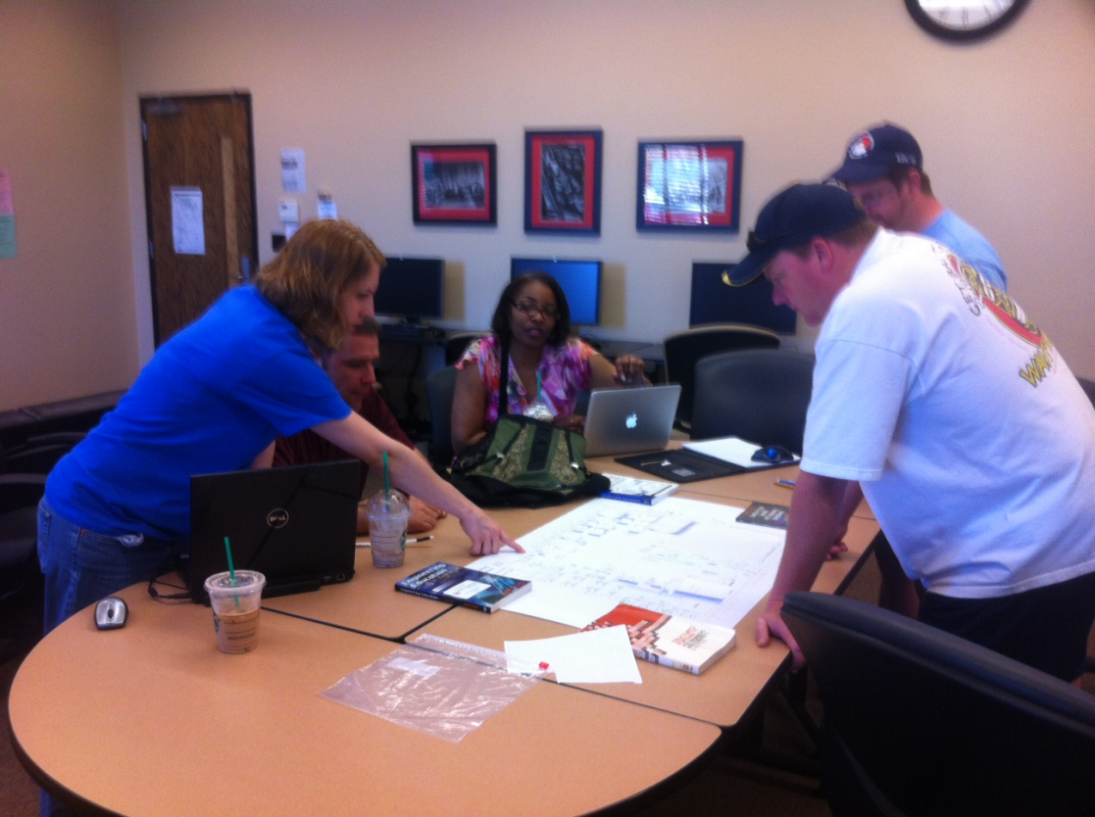
Figure 1: Team Working on Layout

3.1 Test Configurations
There will be 3 design submittals for rating; 2 designed by the Group 3 members on this project and 1 submittal by the SME of the QVC lab. These ratings will be analyzed for consistency and overall success of the project. A determination will be made to re-engineer the plan or continue with the project as planned by the SME.

4.1 Layouts
The team cut out scaled drawings of the different components of the facility and used them to generate feasible layouts for the new QVC floor plan. Below are pictures showing the team working and two designs that are feasible layouts for the QVC move. From these paper doll layouts a solution will be selected and drawn in AutoCAD. The QVC layout team paid particular interest in making sure that proper egress space was allocated for larger parts, and that machines were strategically grouped.
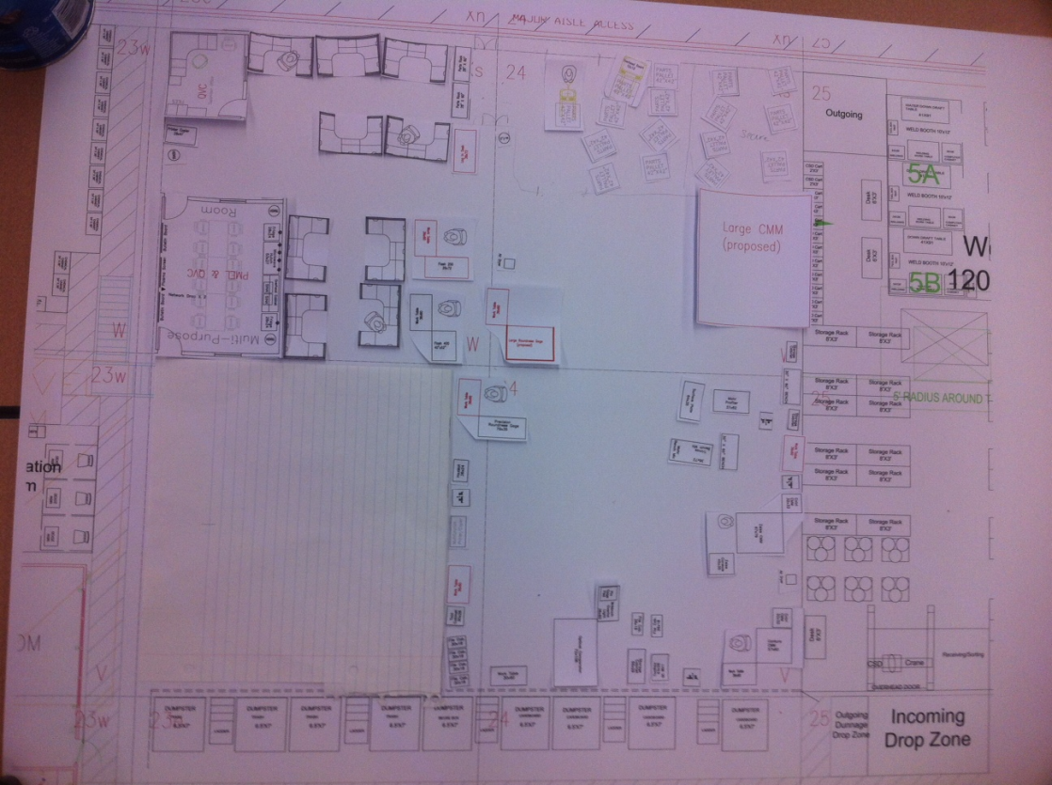

Figure 2: QVC Layout 1

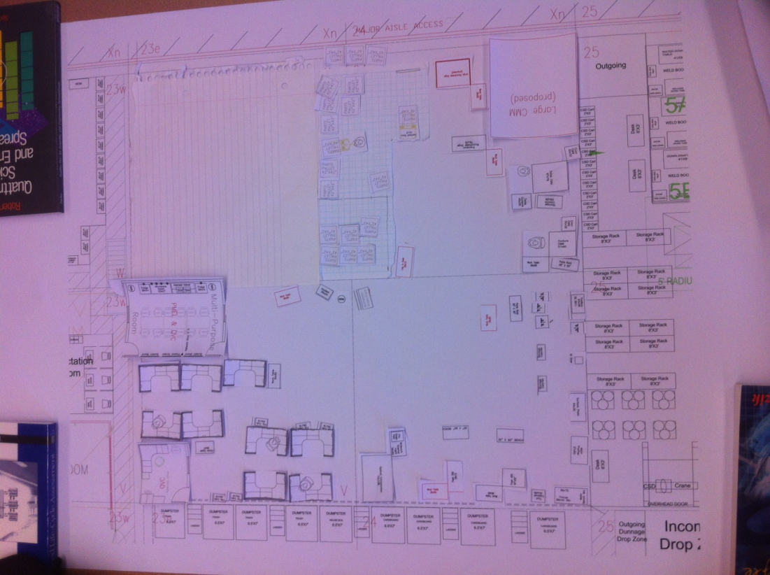

Figure 3: QVC Layout 2

Even though the team divided up into two separate teams to create the layouts, there were certainly some obvious similarities through the natural grouping of equipment and personnel. As it turned out, the second design turned out to be extremely similar to the SME design. After the validation stage the utilization of these tools led the team to select the design created by the SME, those results are shown in the next section.

Figure 4: QVC Final Layout (Design 3)
Once the final design was selected, the team filled out the QVC Layout Validation Checklist to once again validate that the customer requirements were covered by the facility layout.

5.1 Results
The first tool utilized was a SWOT (Strengths, Weaknesses, Opportunities, and Threats) analysis. This allowed the team to review each design subjectively and compare them to one another. The team focused on each designs’ weaknesses and threats as a starting point to begin to guide the team to a selection for the final layout.

As previously mention in 4.1 Layouts, below are the results from the three alternative layout options after each design was ranked based on the set of attributes. This was performed using the Suitability of Design for QVC System Questionnaire by then team, SME, and supervisor ranking eleven criteria attributes on a scale from 1-5. These individual criteria scores were then added for an objective cumulative overall score. Below are the results, which show that the third design is clearly superior to the others.

 | Design 1 | Design 2 | Design 3
Team | 36 | 41 | 49
SME | 39 | 42 | 48
Supervisor | 36 | 42 | 51
 | 111 | 125 | 148

Figure 5: Summary of Questionnaire Overall Scores

The Design Criteria Benchmark Comparison to QVC SME (Subject Matter Expert) Design was used to compare the team Designs 1 & 2 to the SME created design. The team evaluated Design 1 and Design 2 on the same set of attributes used in the Suitability of Design for QVC System Questionnaire to the SME design. Each attribute was selected as Worse, Equivalent, or Better than the SME Design. Below is the summary of these results. This further supported the selection of the SME design since it by far performed the best in the benchmark comparison with the most “Better” responses.

 | Worse | Equivalent | Better
Design 1 | 4 | 7 | 0
Design 2 | 2 | 8 | 1

Figure 6: Summary of Benchmark Comparison Results

6.1 Selection
Once the final design was selected, the QVC Layout Validation Checklist ensured that the selected facility layout design was both the right system (validation) and the system was designed correctly (verification). With this tool, the team reviewed the AutoCAD drawing of the final design and for each requirement selected true or false. Three items were noted as false, but the team, the SME and the supervisor decided these were insignificant requirements and could be added closer to the shop move date.

7.1 Appendix
Attached are copies of the different tools that were used to select the best layout available. For viewing purposes, a larger version of the final layout is also attached at the end.
- SWOT for Design 1
- SWOT for Design 2
- SWOT for Design 3 (SME)
- Suitability of Design for QVC System Questionnaire for Design 1 – Team, SME, Supervisor
- Suitability of Design for QVC System Questionnaire for Design 2 – Team, SME, Supervisor
- Suitability of Design for QVC System Questionnaire for Design 3 – Team, SME, Supervisor
- Design Criteria Benchmark Comparison to QVC SME Design – Design 1
- Design Criteria Benchmark Comparison to QVC SME Design – Design 2
- Final Layout
- QVC Layout Validation Checklist

Design Submittal:__Design 1____________ Reviewer:____Team____________
S.W.O.T.
Strengths | Weaknesses
Similar technologies are within distance of each other.  Open floor plan, optimal part flow (i.e. facilities part flow).  Large acclimation room.  Space for expansion. | Filing and storage system is not optimal. Too scattered.  Medium CMM not under crane system.  Controlled environment space is not well designed for efficiency optimal.  Technology integration is not optimal (i.e. need to move too many pieces of equipment to get it out.)  Isolation from the boss.
Opportunities | Threats
Open space concept such that new workload can be accommodated.  Expansion and upgrading current equipment. | Private contractors contracting workload due to inaccessibility.  QVC Shop is unable to maintain temperature environment.

Design Submittal:__Design 2____________ Reviewer:__Team______________
S.W.O.T.
Strengths | Weaknesses
Open floor plan concept.  Parts flow easily facilitated.  Like equipment grouped together.  Centralized location for tools easily accessible. | Large CMM area does not have accessibility from one side.  Acclimation room entrance comes in from a 90 degree angle.
Opportunities | Threats
Open space concept such that new workload can be accommodated.  Expansion and upgrading current equipment. | Contractor can takeover large item projects as CMM area does not easily accommodate large parts.

Design Submittal:__Design 3____________ Reviewer:__Team______________
S.W.O.T.
Strengths | Weaknesses
Open floor plan concept.  Parts flow easily facilitated.  Like equipment grouped together.  Centralized location for tools easily accessible.  Less wasted space.  More space for PMEL than originally allocated. | Acclimation room entrance comes in from a 90 degree angle.
Opportunities | Threats
Open space concept such that new workload can be accommodated.  Expansion and upgrading current equipment. | Contractor can takeover large item projects as CMM area does not easily accommodate large parts.

Overall Score:__36

Overall Score:__39_____

Overall Score:__36_____

Overall Score:__41_____

Overall Score:__42_____

Overall Score:__42_____

Overall Score:__49____

Overall Score:__48_____

Overall Score:__51_____

Final Layout:

Attached is also a checklist that denotes requirements completed on the selected design.

QVC Layout Validation Checklist |  | TRUE | FALSE
1 System Requirements
1.1 | Are double doors used for entries into the facility? | X
1.2 | Is there an overhead crane? | X
1.3 | Are proper utilities,100 psi air and 120v electricity, in place for proposed layout of machinery? | X
1.4 | Are proper environmental controls in place? | X
1.5 | Are emergency signs and lights in place? | X
1.6 | Is security being taken account in the design? | X
1.7 | Is a lifespan of 30 years taken into account for this layout? | X
1.8 | Does the Gantry Crane have sufficient lift for larger parts? | X
1.9 | Has the engineering department at Tinker approved this design? | X
1.10 | Are network ports highlighted for this design? |  | X
1.11 | Is documentation thorough enough for implementation | X
2 Facility Space
2.1 | Is there and acclimation space? | X
2.2 | If there is an overhead crane is it positioned to move correctly over larger pieces of equipment? | X
2.3 | Is there enough room for egress of larger parts through the boundaries and inside of the facility layout? | X
2.4 | Are column beams being taken into account for this layout? | X
2.5 | Is there room for additional machinery? | X
2.6 | Are there double doors into the facility that are at least 6.5 feet? | X
2.7 | Are there double doors into the facility that are at least 10 feet tall? | X
2.8 | Are doors wide enough to handle larger diameter parts? | X
2.9 | Is the acclimation space large enough to handle a suitable number of parts? | X
2.10 | Is there enough room in the office space for 1 manager and 7 employees? | X
3 People/Safety
3.1 | Is there sufficient Office Space? | X
3.2 | Is there a conference room? | X
3.3 | Is there a space for PMEL? | X
3.4 | Are suitable restroom facilities accessible easily? | X
3.5 | Is there access according to the Americans with Disabilities Act? | X
3.6 | Is the a floor marking layout for safety striping? |  | X
3.7 | Has proper lighting with respect to an ergonomic workplace been taken into account for this design? | X
3.8 | Are aisles clearly marked? |  | X
4 Machine
4.1 | Do all current machines fit in proposed design? | X
4.2 | Is part flow taken into account for this design? | X
4.3 | Are machines laid out in a methodical manner? | X
4.4 | Is vibration being taken into account in design for sensitive machinery? | X
4.5 | Is the current foundation being taken into account for the heavier machinery? | X
4.6 | Are machines clearly laid out with appropriate dimensions and directions? | X
4.7 | Are machines grouped according to function? | X
4.8 | Can fork lifts and hand trucks easily maneuver to required machinery? | X

Management Concept Exploration Document (M6)
Group 3 - Andy Lee, Mary Gravette, Andrew Freeman, Ira Bryant, Terry Anderson, Jose Berrios
March 14, 2012
1.1 Concept Exploration 105
2.1 Alternative System Designs 105
3.1 Propose Configuration/Architecture of System 105
4.1 Sensitivity Analysis 107
5.1 Do Nothing Alternative 107
6.1 References 107

1.1 Concept Exploration
The steps taken to create a functional and effective facility layout can quickly become a complex system design. The equipment’s inherent characteristics are complex and external requirements may differ. For example, equipment sizes range from hand held devices to room size industrial equipment. Several design parameters must be met in order for the overall facility and components to function efficiently, safely, and accurately. Therefore, care should be taken when deciding which process will be followed. In this section, we will concentrate our efforts on analyzing different methods to design layouts and decide which method best meet the requirements.

2.1 Alternative System Designs
There are three methods for approaching the design of industrial facility layouts that are considerations for alternate system designs.
- Mathematical Model: This type of process involves a framework for finding competitive solutions for the layout. One math model found during research involves finding starting points for the iterative algorithm to be input into to a second model. The second model formulates the facility layout problem as a nonconvex mathematical program with equilibrium constraints (MPEC). Aspect ratio constraints restrict the occurrence of overly long and narrow departments in the computed layouts. The computational results show the complete framework can be solved efficiently. The framework can be used to find different layouts with little computational effort, which is advantageous for a user who wishes to consider several competitive layouts rather than simply using a mathematically optimal layout. [1]
- Computer Simulation: A comprehensive simulation study was undertaken to determine the inherent constraints and the bottleneck operations in the manufacturing process. The relevant performance measures from the simulation outputs along with such factors as space requirements for each equipment and the expected production goal of the new facility were analyzed to present facility design alternatives for the proposed new facility. [2]
- Layout Exercise: This type of method utilizes the paper doll tactic and allows the users to play around with the equipment inside the allotted space and get a feel for the various options. This is similar to a trial and error method where the team can arrange the equipment in the block in a logical flow or sequence manner. The next step involves comparing the layouts to one another with their strengths, weaknesses, opportunities, and threats. Another option is to use a decision selection matrix where the team will score and rank the layout options such as adjacency, least travel distance, etc. [3]

With any of the above methods, the next step will be to place the layout chosen in AutoCAD for viewing purposes.

3.1 Propose Configuration/Architecture of System
Due to time and budget constraints, the third option of performing a layout exercise is the best method for this project.

The procedure for developing the design can be seen in Figure 1. We will split our team into two, and develop layouts independently using a process layout. Each design will be evaluated to make sure it meets the derived requirements. We will then perform a Strength, Weaknesses and Threat Analysis on each design. The two designs will be compared. A compromise design will be created based on the two designs. This design will be verified and validated, with input from QVC personnel. A final design will then be determined.

Figure 1: Design Development Strategy

Review Derived Requirements

Split Into Two Teams

Develop
Independent Layout
Develop
Independent Layout
Verify and Validate Requirements

Perform Strength, Weaknesses, Opportunities and Threat Analysis on Each Design

Develop Compromise Design

QVC Personnel Input
Verify and Validate Requirements

Develop Final Layout

4.1 Sensitivity Analysis
Since a quantifiable measureable objective is hard to apply to this project of designing a new layout for the QVC lab, a sensitivity analysis will not be performed. Sensitivity analysis generally involves changing parameters of a system or function in order to determine the effects of different levels of variables, or whether some variable are even present or not. Again because there is not a quantifiably measureable objective here one will not be performed. In the future when this layout is put into place, a future project team could perform a sensitivity analysis by changing particular movers, days the move is carrier out, or the particular order of the move.

5.1 Do Nothing Alternative
If nothing is done to start planning the move of the current facility there is a slight possibility, however unlikely, that Aircraft at Tinker will not be building a new hangar in its place. If Aircraft does not build a new hangar and nothing is done to prepare for the move time will be saved by the students and QVC personnel by not having to plan for the move. Since the aforementioned possibility is very slim, the “do nothing alternative” will not be sufficient in this case. Doing nothing could result in a last minute scramble to move sensitive equipment in order to make way for the new hangar. This quick move could possibly damage equipment and create more costs for Tinker than what would be necessary by planning the move beforehand, as well as creating an inefficient and ineffective facility layout for the QVC shop.

6.1 References
[1] http://joc.journal.informs.org/content/18/1/111.abstract
[2] http://ieeexplore.ieee.org/xpls/abs_all.jsp?arnumber=746025&tag=1
[3] http://www.resourcesystemsconsulting.com/blog/archives/tag/facility-layout

Project Concept Exploration Document (P6)
Group 3 - Andy Lee, Mary Gravette, Andrew Freeman, Ira Bryant, Terry Anderson, Jose Berrios
March 5, 2012
1.1 Concept Exploration 109
2.1 Alternative System Designs 109
3.1 Propose Configuration/Architecture of System 109
4.1 Sensitivity Analysis 111
5.1 Do Nothing Alternative 111

1.1 Concept Exploration
The development of a functional and effective facility layout is a complex system design. The equipment’s inherent characteristics are complex and external requirements may differ. For example, equipment sizes range from hand held devices to room size industrial equipment. Several design parameters must be met in order for the overall facility and components to function efficiently, safely, and accurately. For example, in order to accomplish this task the equipment external requirements must be met (Power, clearances, environment, etc.) in order for the project to be successful. Therefore, extreme care should be taken when deciding which concept must be followed. In this section, we will concentrate our efforts on analyzing different layouts and decide which concept best meet the customer’s requirements.

2.1 Alternative System Designs
There are generally two abstract methods for approaching the design of industrial facility layouts.
- Process Layout: This type of layout focuses on grouping machinery and workstations according to their overall function. Such as grouping lathes with other lathes, or grouping de-burring equipment with rough cutting equipment. This type of layout is useful when multiple different product types are expected to be flowing through the system. In the case of the QVC multiple parts of differing dimensions will be flowing through the system so a process layout will probably be what is focused on when coming up with the final detailed design of the proposed layout.
- Product Layout: This type of layout focuses on the flow of a particular product, or type of product, through a facility. Machines are generally placed in the order that they will be used in the product flow. Because of the QVC’s unique job of measuring and analyzing multiple different parts from all over Tinker creating a product layout which would insure an effective process would be difficult.

Once the type of layout has been determined a second question has to be taken into account. Will the floor plan be designed around the machinery and required office equipment or will the floor plan be designed around planned space available, i.e. aisle ways, clearances etc. Since in the future the QVC is expected to handle even larger pieces of equipment than it does currently, it might be advantageous to consider designing around the required space for moving larger parts in and out of the facility.

3.1 Propose Configuration/Architecture of System
Because of the nature of the project, a true analysis of alternate system designs will have to be accomplished after a design model (CAD layout of proposed area) has been developed.

The procedure for developing the design can be seen in Figure 1. We will split our team into two, and develop layouts independently using a process layout. Each design will be evaluated to make sure it meets the derived requirements. We will then perform a Strength, Weaknesses and Threat Analysis on each design. The two designs will be compared. A compromise design will be created based on the two designs. This design will be verified and validated, with input from QVC personnel. A final design will then be determined.

Figure 1: Design Development Strategy

Review Derived Requirements

Split Into Two Teams

Develop
Independent Layout
Develop
Independent Layout
Verify and Validate Requirements

Perform Strength, Weaknesses, Opportunities and Threat Analysis on Each Design

Develop Compromise Design

QVC Personnel Input
Verify and Validate Requirements

Develop Final Layout

4.1 Sensitivity Analysis
Since a quantifiable measureable objective is hard to apply to this project of designing a new layout for the QVC lab, a sensitivity analysis will not be performed. Sensitivity analysis generally involves changing parameters of a system or function in order to determine the effects of different levels of variables, or whether some variable are even present or not. Again because there is not a quantifiably measureable objective here one will not be performed. In the future when this layout is put into place, a future project team could perform a sensitivity analysis by changing particular movers, days the move is carrier out, or the particular order of the move.

5.1 Do Nothing Alternative
If nothing is done to start planning the move of the current facility there is a slight possibility, however unlikely, that Aircraft at Tinker will not be building a new hangar in its place. If Aircraft does not build a new hangar and nothing is done to prepare for the move time will be saved by the students and QVC personnel by not having to plan for the move. Since the aforementioned possibility is very slim the “do nothing alternative” will not be sufficient in this case. Doing nothing could result in a last minute scramble to move sensitive equipment in order to make way for the new hangar. This quick move could possibly damage equipment and create more costs for Tinker than what would be necessary by planning the move beforehand.

Management Design Model Document (M7)
Group 3 - Andy Lee, Mary Gravette, Andrew Freeman, Ira Bryant, Terry Anderson, Jose Berrios
March 14, 2012
1.1 Design Model Goal 113
2.1 Deliverables 113
3.1 Diagram Creation 113
4.1 Schedule 115
5.1 Assignments to QVC Relocation Team Members 117

1.1 Design Model Goal
At the completion of part P7 of the QVC relocation facility the group will have generated a detailed floor layout plan which will be used during the relocation of the QVC lab. This document will describe the P7 deliverables and who is responsible for which parts of the P7 document. A schedule will be followed in order to insure that P7 is delivered on time to our customers on April 23rd, 2012. Throughout the entire process the group will constantly reevaluate the progress of the corresponding project work. This continual reevaluation will insure that the students are on track to a viable solution.

2.1 Deliverables
Below is a list of required deliverables for the design model of the QVC relocation project. These deliverables will be tentatively due to our instructor on 4/23/2012.
- AutoCAD drawings of the selected floor layout plan which will include
  - Office locations
  - Break room location
  - Storage locations
  - Acclimation room location
  - Machine locations
  - Utility drawings
  - PMEL location
  - Egress pathways
  - Entrances and exits
  - Safety equipment location: fire extinguishers etc.
  - Gantry crane location and service area
- Class diagram
- Activity diagram

3.1 Diagram Creation
Two types of diagrams will be created to show the relationship between activities and classes of equipment, respectively an activity diagram and a class diagram. The activity diagram will show the relationship and precedence of multiple steps through the life of a part that is being measured by the QVC laboratory. This activity diagram will show a basic roadmap of a part that will travel within the boundary of the QVC system. The part will progress through the different functions the QVC system until the part and its generated documentation exits the system.

The class diagram represents the different types, or classes, of machinery and tools that will be located in the QVC facility. When designing larger complex systems this methodological approach to visually mapping the different tools at hand insures that everything that is needed for the system to function properly has been included. Classes and there corresponding methods, or functions, will only be included if they lie within the predetermined scope of the system. It is important to insure that these different classes and their corresponding functions are generating what is required, whether that is data, parts, or energy, to later be passed or interact with the outside environment located outside of the defined system scope. Examples of the two deliverable diagrams are located below.

Figure 1: Activity Diagram of QVC
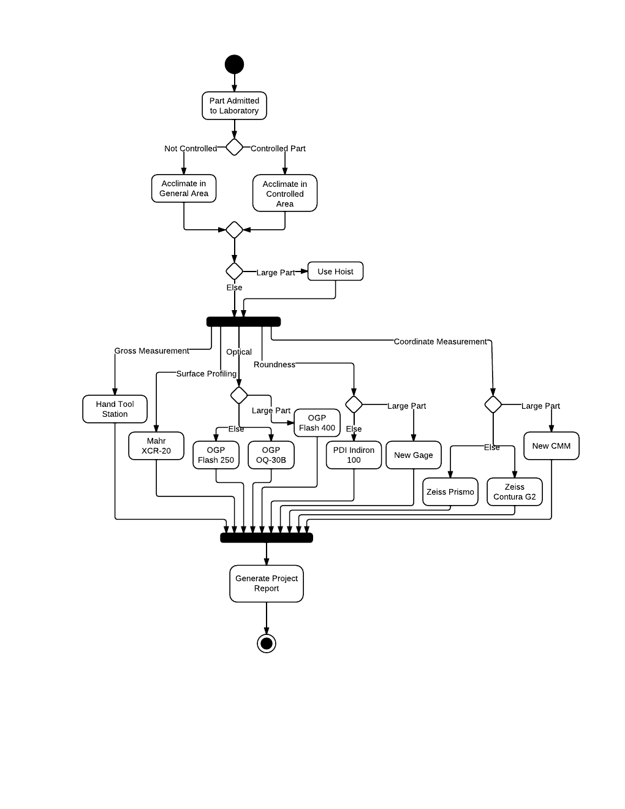

Figure 2: Class Diagram of QVC
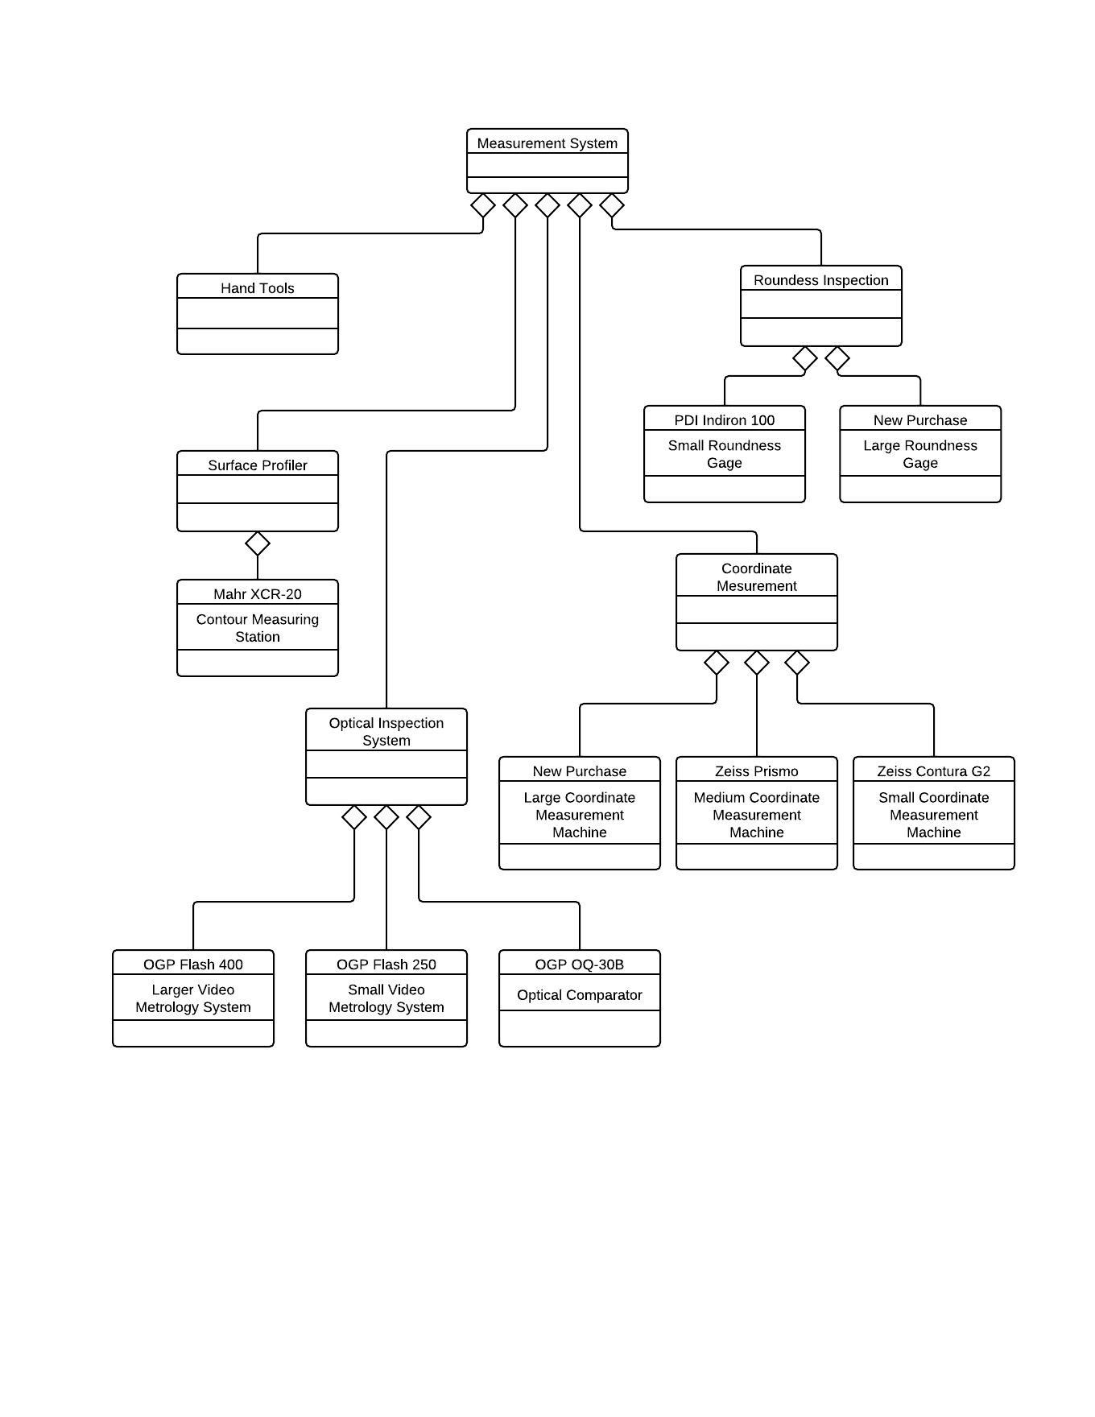

4.1 Schedule

Figure 3: QVC Layout Gantt Chart (Highlighted box indicates current task that P7 will be focusing on)

Figure 3: QVC Layout Design Roadmap (Highlighted boxes indicate current steps that P7 will be tackling)

5.1 Assignments to QVC Relocation Team Members
Tasks have been assigned according to team member expertise in the defined areas. All team members will have an input on all assigned tasks handed out during this section. Team members are expected to adhere to the team member contract which was updated on 3/7/2012 and agreed to by all members. Laid out below are the assigned tasks that each team member will be expected to carry out during this month and half long process.

Andy Lee: Subject matter expert on this system so his input will be vital. Help with the drawing of the layout of the proposed layout.

Mary Gravette: Manage the status of the process and make sure deliverable deadline will be met.

Andrew Freeman: Help with the drafting of the proposed layout.

Ira Bryant: Create the activity and network diagrams.

Terry Anderson: Measure and rank the proposed solutions.

Jose Berrios: Validate and verify the design.

Project Design Model Document (P7)
Group 3 - Andy Lee, Mary Gravette, Andrew Freeman, Ira Bryant, Terry Anderson, Jose Berrios
April 23, 2012
1.1 Design Model Goal 119
2.1 Deliverables 119
3.1 Diagram Creation 119
4.1 Final Design 123
5.1 Schedule 124
6.1 Assignments to QVC Relocation Team Members 124

Design Model Goal
The group generated a detailed floor layout plan which will be used during the relocation of the QVC lab. This document will describe the P7 deliverables and who is responsible for which parts of the P7 document. A schedule was followed in order to insure that P7 is delivered on time to our customers on April 23rd, 2012. The team utilized the documents created in P4 to verify and validate the results. This continual reevaluation ensured that the students were on track to the viable solution.

2.1 Deliverables
Below is a list of required deliverables for the design model of the QVC relocation project. These deliverables will be tentatively due to our instructor on 4/23/2012.
- Class diagram
- Activity diagram
- AutoCAD drawings of the selected floor layout plan which will include
  - Office locations
  - Break room location
  - Storage locations
  - Acclimation room location
  - Machine locations
  - Utility drawings
  - PMEL location
  - Egress pathways
  - Entrances and exits
  - Safety equipment location: fire extinguishers etc.
  - Gantry crane location and service area

3.1 Diagram Creation
Unified Modeling Language (UML) diagrams were originally developed to show the structure of object-oriented programs. These diagrams have been adapted to show the structure of more generalized processes. The UML diagrams developed for this project show the relationship and precedence of multiple steps through the life of a part that is being measured by the QVC laboratory. This activity diagram shows a basic roadmap of a part as it travels within the boundary of the QVC system. The part progresses through the different functions the QVC system until the part and its generated documentation exits the system. This diagram shows an idealized process, an actual part moving through the system may not undergo each and every process in the system.

The class diagram represents the different types, or classes, of machinery and tools that will be located in the QVC facility. When designing larger complex systems this methodological approach to visually mapping the different tools at hand insures that everything that is needed for the system to function properly has been included. Classes and there corresponding methods, or functions, will only be included if they lie within the predetermined scope of the system. It is important to insure that these different classes and their corresponding functions are generating what is required, whether that is data, parts, or energy, to later be passed or interact with the outside environment located outside of the defined system scope. The class diagram here is relatively simple, because the project is limited to just the facility layout. The class diagram could be modified to include shared OEMs between the machines or common maintenance contractors. Examples of the two deliverable diagrams are on the next two pages.

Figure 1: Activity Diagram of QVC

Figure 2: Class Diagram of QVC

4.1 Final Design
Based on the results from the SWOT (Strengths, Weaknesses, Opportunities, and Threats), Suitability of Design for QVC System Questionnaire, and Design Criteria Benchmark Comparison to QVC SME Design the team to selected the below facility layout.

Figure 3: Final Facility Layout of QVC Lab

5.1 Schedule

Figure 4: QVC Layout Gantt Chart (Highlighted box indicates current task that P7 will be focusing on)

Figure 5: QVC Layout Design Roadmap (Highlighted boxes indicate current steps that P7 will be tackling)

6.1 Assignments to QVC Relocation Team Members
Tasks have been assigned according to team member expertise in the defined areas. All team members will have an input on all assigned tasks handed out during this section. Team members are expected to adhere to the team member contract which was updated on 3/7/2012 and agreed to by all members. Laid out below are the assigned tasks that each team member will be expected to carry out during this month and half long process.

Andy Lee: Subject matter expert on this system so his input will be vital. Help with the drawing of the layout of the proposed layout.

Mary Gravette: Manage the status of the process and make sure deliverable deadline will be met.

Andrew Freeman: Help with the drafting of the proposed layout.

Ira Bryant: Create the activity and network diagrams.

Terry Anderson: Measure and rank the proposed solutions.

Jose Berrios: Validate and verify the design.

Management Mappings and Management Document (M8)
Group 3 - Andy Lee, Mary Gravette, Andrew Freeman, Ira Bryant, Terry Anderson, Jose Berrios
February 27, 2012
1.1 Mapping between documents 127
2.1 User’s Manual 128
3.1 Risk Management 128
4.1 Pert Chart 131
5.1 Work Breakdown Structure 132
6.1 Schedules 132
7.1 Glossary 134

1.1 Mapping between documents
This Unified Modeling Language (UML) diagram shows the linkages between each of the eight documents that have been completed during this project.

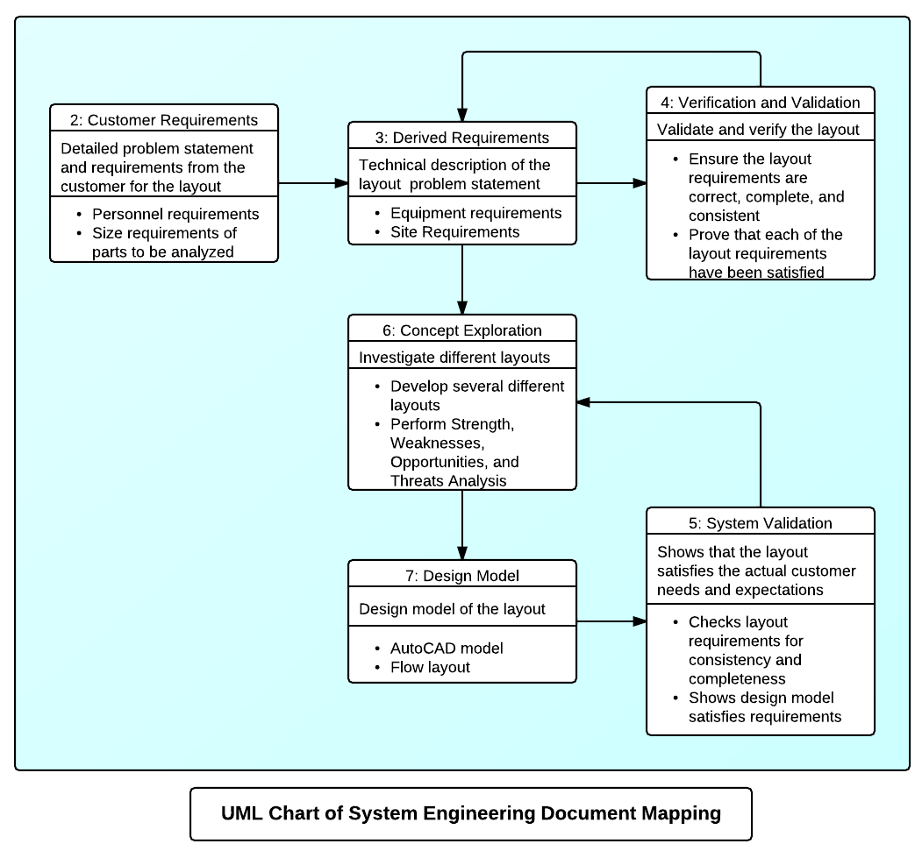

Figure 1: QVC Facility Layout Mapping.

2.1 User’s Manual
The following is the roadmap for another team to duplicate the steps that have been taken to replicate a similar project.

    - Management identifies an issue that needs a solution.
    - Brainstorm the process and steps that needs to be taken to accomplish the solution to produce direction and focus.
    - Identify potential personnel skills that would be required.
    - Create a team contract to generate a sense of unity.
    - Identify the customer requirements.
    - Identify the technical requirements.
    - Document steps taken and share these documents with each team member.
    - Identify alternative processes to get the solution.
    - Verify that the steps taken are the correct steps.
    - Document lessons learned to avoid same mistakes being made.

3.1 Risk Management
Risk management is the identification, assessment, prioritization and management of risks. This assessment will identify and mitigate those risks.

  - 3.1 • Identification
The risks associated with the QVC facility layout are identified below.
      - Personnel possess the required skills. These include
        - Drafter with CAD knowledge
        - Structural engineer to evaluate the feasibility of the layout
        - Electrician to assure that proper power source is available for the equipment
        - Safety engineer to ensure that placement of equipment does not interfere in case of an emergency situation
      - Schedule
        - Meet Tinker AFB deliverable date for facility layout
        - Meet System Engineering course deliverable date
        - Adapt to changing schedules (i.e. task due dates )
      - Personal and professional conflicts
        - Personal – sickness or emergency
        - Professional – travel, overtime, etc.
      - Lack of Systems Engineering knowledge
        - Inadequate understanding of the interface between new shop and surrounding threats (i.e. vibrations impacting location of equipment).
        - Inadequate understanding of the workflow interface between the customer and Quality Verification Center.
      - Communication
        - The Oklahoma University’s Desire 2 Learn (D2L) is inaccessible.
        - Tinker AFB email system is inaccessible.
        - Team members unable to attend scheduled meetings.
      - Product Approval
        - The validation and evaluation does not meet the approval of Tinker AFB.
        - The final product does not meet the instructor’s approval.
      - Scope creep
        - Team members develop requirements and/or taskings outside of the project scope.
        - Customer requirements increase and / or change.

3.2 • Assessment

The risks are assessed taking into consideration the probability and impact of occurrence for each risk. After identifying the probability and impact of the risks they will be plotted on a classic risk analysis matrix. Due to the nature of the project the data is qualitative. The probability will be rated as follows,
- High (>75% of occurrence)
- Medium (25%<probability<75%)
- Low (<25%).

Similarly the impact of the risk will be categorized as follows,
- High (Great impact to project cost, schedule, or performance)
- Medium (Slight impact to project cost, schedule, or performance)
- Low (Little impact on cost, schedule or performance)

Risks assessment
The risk will be followed by the probability and impact using the guidelines described above,
- Personnel possess the required skills (Low, Low)
- Schedule , (Low, Low)
- Personal and professional conflicts (Medium, Medium)
- Lack of Systems Engineering knowledge (Medium, Medium)
- Communication (Medium, Medium)
- Product Approval (Low, High)
- Scope Creep (High, Medium)

Impact | H | f
Impact | M |  | c,d,e | g
Impact | L | a,b,
Impact |  | L | M | H
 | Probability

Figure XX: QVC Facility Layout Risk Diagram.

Risks that fall under the yellow and red will include risk response.

3.3 • Risk Response
First the risks will be discussed and an approach method will be selected to address it. There are four major approaches for risk response. These are avoidance which eliminates the cause, mitigation in which we define ways to reduce the probability and impact of the risk, transfer which makes another party responsible, and finally acceptance where nothing is done.

In our project since the risks identified in the previous section will be addressed by the following approaches:

- Personnel possess the required skills accept
- Schedule accept
- Personal and professional conflicts accept
- Lack of Systems Engineering knowledge avoid
- Communication mitigate
- Product Approval avoid
- Scope Creep avoid

The following approaches will be used to either mitigate or avoid the potential risks identified:

c) If team members have personal or professional conflicts with team meetings or class schedule, the team will accept the risk and bring team member up to speed. Additionally, team member may be available to participate via distant communication.

d) To avoid the lack of systems engineering knowledge, the team will review the documents with Dr. Allen and Tinker AFB customer.

e) In order to mitigate the risk of Communication via either the Oklahoma University’s Desire 2 Learn (D2L) or Tinker AFB email system are inaccessible, or team members are unable to attend scheduled meetings; the group will use personal devices to communicate.

f) The team will avoid the Product Approval risk by staying in constant communication with Dr. Allen and Tinker AFB.

g) The team will avoid the risk of Scope Creep by providing a continuous sanity check, re-evaluating, and working in a team environment.

3.4 • Risk Monitoring
All stakeholders in the project are required to track, monitor and report risks throughout the duration of the project. Any project additions will be evaluated following the guidelines mentioned above and all stakeholders will be notified of changes in risk status.

4.1 Pert Chart
The following Pert Chart shows the schedule and limitations for the QVC Facility Layout with the critical path being highlighted.

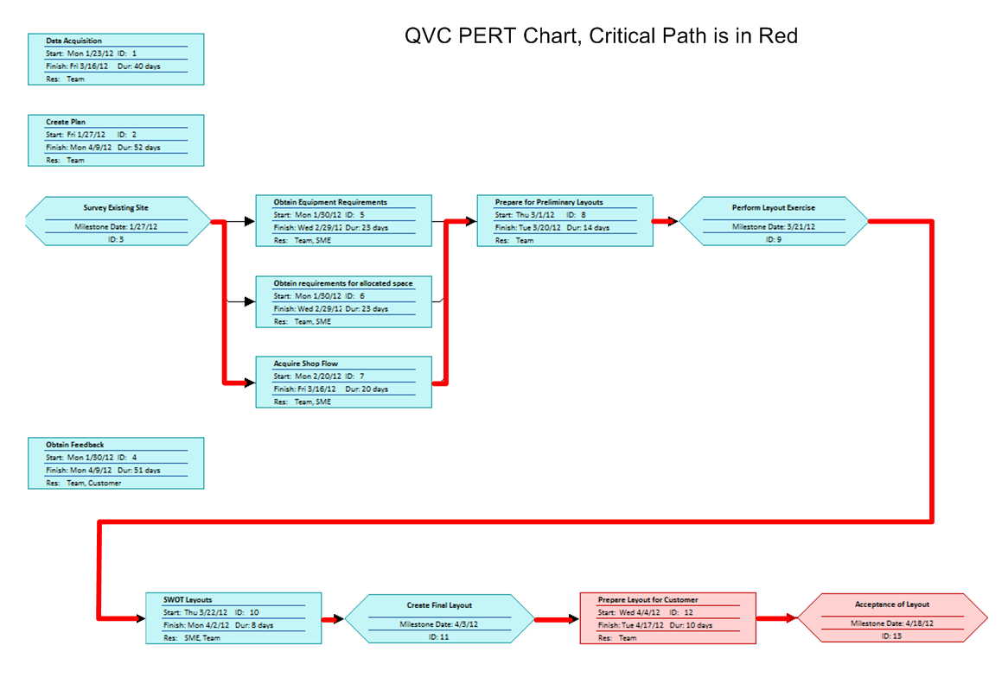

Figure 2: QVC Facility Layout Pert Chart.

5.1 Work Breakdown Structure
The following shows the Work Breakdown Structure (WBS) of the QVC Facility Layout.

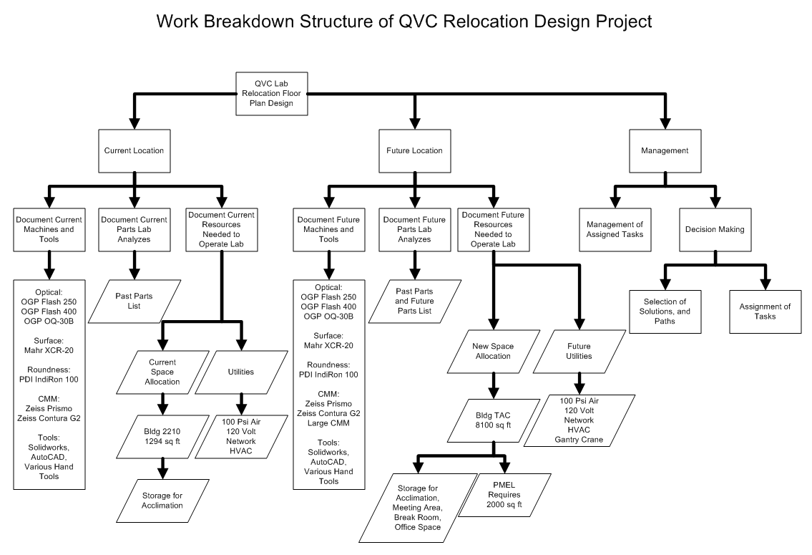
Figure 3: QVC Facility Layout WBS

6.1 Schedules
The detailed schedule requirements of the QVC Facility Layout are shown in the Gantt chart below. There is also a direct correlation to the Systems Engineering Diagram following it. They have been connected by a numbering system (0-6) to identify the steps being taken in each diagram.

Figure 4: QVC Facility Layout Gantt chart

Figure 5: QVC Facility Layout Systems Engineering Diagram

7.1 Glossary

AFMAN – Air Force Manual – contains information, policy, procedures, and mobility instructions.

AMXG – Aircraft Maintenance Group

ASME – American Society of Mechanical Engineers

B2210 – Building 2210 on Tinker AFB - houses QVC lab for transfer to TAC facility.

CAD – Computer Aided Design

COTS – Commercial Off The Shelf

MXSG – Maintenance Support Group

SME – Subject Matter Expert

QVC – Quality Verification Center – provides precision measurement for all aircraft engines, components, parts, and aircraft commodities, conventional and advanced weapon systems and subsystems .

TAC – Tinker Aeronautical Center – Name given to building 9001 on Tinker AFB. This building houses multiple organizations that provide services during the industrial processes of aircraft, engines, commodities

Project Mappings and Management Document (P8)
Group 3 - Andy Lee, Mary Gravette, Andrew Freeman, Ira Bryant, Terry Anderson, Jose Berrios
February 27, 2012
1.1 Mapping between documents 137
2.1 User’s Manual 138
3.1 Risk Management 138
4.1 Pert Chart 140
5.1 Work Breakdown Structure 141
6.1 Schedules 141
7.1 Glossary 143

1.1 Mapping between documents
This Unified Modeling Language (UML) diagram shows the linkages between each of the eight documents that have been completed during this project.

Figure 1: QVC Facility Layout Mapping.

2.1 User’s Manual
The following is the roadmap for another team to duplicate the steps that have been taken to replicate a similar project.

    - Accept managements defined problem
    - Create a team contract to generate a sense of unity.
    - Obtain all data needed.
      - Gather the customer requirements.
        - Personnel requirements.
        - Size requirements of the part to be analyzed.
      - Gather the technical requirements.
        - Equipment requirements.
        - Site requirements.
      - Understand how parts move through the QVC shop.
    - Identify several feasible solutions.
    - Validate that the solutions meet the requirements.
    - Compare the options and do a Strength, Weaknesses, Opportunities, and Threats (SWOT) to determine if one option will be selected or a compromise of the options will need to be made.
    - Verify the solution.
    - Make any final changes that may be required.
    - Submit final layout.
    - Document lessons learned to avoid same mistakes being made.

3.1 Risk Management
Risk management is the identification, assessment, prioritization and management of risks.

  - 3.1 • Identification
The risks associated with the QVC facility layout are identified below.
      - Not enough space for the equipment
        - The new facility/space might not have enough space for current or future applications
      - Improper clearance between equipment
        - Equipment required clearances in order to be operated safely and efficiently may be compromised
      - Improper power source (electrical, pneumatic or hydraulic)
        - Required sources of energy for the equipment might not be present
      - Clean room requirement not met
        - Room needs to meet clean room requirement 300,000 class
      - Backlog on work orders (overcrowding of parts)
        - Accumulation of parts might occur and create a hazardous environment

3.2 • Assessment

The risks are assessed taking into consideration the probability and impact of occurrence for each risk. After identifying the probability and impact of the risks they will be plotted on a classic risk analysis matrix. Due to the nature of the project the data is qualitative. The probability will be rated as follows,
- High (>75% of occurrence)
- Medium (25%<probability<75%)
- Low (<25%).

Similarly the impact of the risk will be categorized as follows,
- High (Great impact to project cost, schedule, or performance)
- Medium (Slight impact to project cost, schedule, or performance)
- Low (Little impact on cost, schedule or performance)

Risks assessment
The risk will be followed by the probability and impact using the guidelines described above,
- Space Requirement, (Low, Low)
- Improper clearance, (Low, Low)
- Improper power source, (Low, Low)
- Clean room requirement (Low, Low)
- Backlog on work orders (Med, Med)

Impact | H
Impact | M |  | e
Impact | L | a,b,c,d
Impact |  | L | M | H
 | Probability

Figure XX: QVC Facility Layout Risk Diagram.

Risks that fall under the yellow and red will include risk response.

3.3 • Risk Response
First the risks will be discussed and an approach method will be selected to address it. There are four major approaches for risk response. These are avoidance which eliminates the cause, mitigation in which we define ways to reduce the probability and impact of the risk, transfer which makes another party responsible, and finally acceptance where nothing is done.

In our project since the risks identified in the previous section will be addressed by the following approaches,
- Space Requirement, acceptance
- Improper clearance, acceptance
- Improper power source, acceptance
- Clean room requirement acceptance
- Backlog on work orders mitigation

In order to mitigate the risk of backlog on work orders the following measures will be put on place,
- Management will be advised in advance of movement of equipment
- Amount of down time for equipment will be determined
- Planning will route parts according to predicted down time

3.4 • Risk Monitoring
All stakeholders in the project are required to track, monitor and report risks throughout the duration of the project. Any project additions will be evaluated following the guidelines mentioned above and all stakeholders will be notified of changes in risk status.

4.1 Pert Chart
The following Pert Chart shows the schedule and limitations for the QVC Facility Layout with the critical path being highlighted.
Figure 2: QVC Facility Layout Pert Chart.

5.1 Work Breakdown Structure
The following shows the Work Breakdown Structure (WBS) of the QVC Facility Layout.

Figure 3: QVC Facility Layout WBS

6.1 Schedules
The detailed schedule requirements of the QVC Facility Layout are shown in the Gantt chart below. There is also a direct correlation to the Systems Engineering Diagram following it. They have been connected by a numbering system (0-6) to identify the steps being taken in each diagram.

Figure 4: QVC Facility Layout Gantt chart

Figure 5: QVC Facility Layout System Engineering Diagram

7.1 Glossary

AFMAN – Air Force Manual – contains information, policy, procedures, and mobility instructions.

AMXG – Aircraft Maintenance Group

ASME – American Society of Mechanical Engineers

B2210 – Building 2210 on Tinker AFB - houses QVC lab for transfer to TAC facility.

CAD – Computer Aided Design

COTS – Commercial Off The Shelf

MXSG – Maintenance Support Group

SME – Subject Matter Expert

QVC – Quality Verification Center – provides precision measurement for all aircraft engines, components, parts, and aircraft commodities, conventional and advanced weapon systems and subsystems .

TAC – Tinker Aeronautical Center – Name given to building 9001 on Tinker AFB. This building houses multiple organizations that provide services during the industrial processes of aircraft, engines, commodities

